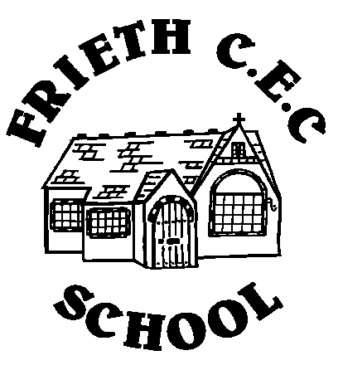**Owls Class – Spring Term**

|  |  |  |  |  |  |
| --- | --- | --- | --- | --- | --- |
|  | **Monday – MB**  **LSA – SB, ES** | **Tuesday - MB**  **LSA – SB** | **Wednesday – MB**  **LSA – SB, ES** | **Thursday – MB, SB**  **LSA – ES** | **Friday – MB**  **LSA – StB, LS** |
| 8:45 - 9:00 | Registration  Morning Work | Registration  Morning Work | Registration  Morning Work | Registration  Morning Work | Registration  Morning Work |
| 9:00 – 10:00 | Phonics  Handwriting | Phonics  Handwriting | Phonics  Handwriting | Phonics  Handwriting | Phonics  Handwriting |
| Fruit and milk |
| 10:00 - 10:15 | Snack and Milk | Church led Collective Worship | Snack and milk | Snack and milk | Snack and milk |
| 10:15 - 10:30 | B | R | E | A | K |
| 10:30 - 12.05 | Mastering Number/  White Rose Maths | Mastering Number/  White Rose Maths | Mastering Number/  White Rose Maths | Mastering Number/  White Rose Maths | Mastering Number/  White Rose Maths |
| Independent Learning | Independent Learning | Independent Learning | Independent Learning | Independent Learning |
| 12:15 - 1:15 | L | U | N | C | H |
| 1:15 - 2:15 | Registration | Registration | Registration | Registration | Registration |
| Teacher Input | P.E. | Teacher Input | Library | PSHE |
| 2:15 - 3:00 | Independent Learning | Independent Learning | Independent Learning | P.E. |
| Collective Worship | Collective Worship | Collective Worship |