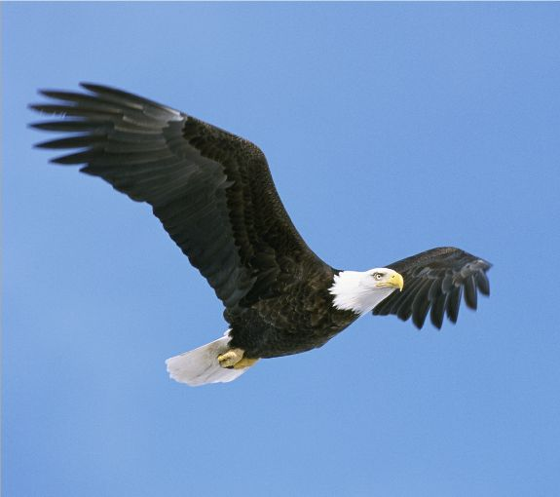

Eagles Curriculum Information

Autumn Term 2023

Hello and welcome back to the new school year! This year your child will be taught by Mrs Lampard, who is new to Frieth school, and Mr Gosling. We are excited to be back in the classroom for the new term and are anticipating a great year ahead with your children. Many exciting and varied things are planned for the year and we are looking forward to working in partnership with you to ensure that your child’s final year is a positive and fulfilling one. This year, Eagles will be taught by Mrs Lampard on Mondays, Tuesdays and Wednesdays, Mr Gosling on Thursdays and Fridays; we will also be supported by Mrs Goodchild and Mrs Spencer.

Over the course of this term, the main topics covered will be ‘Ancient Mayan Civilisation’ and ‘The Amazing Americas’, which will both be taught creatively across the curriculum.

English
The English programme of study is divided into three core units of Narrative, Non-Fiction and Poetry. These are studied in a variety of ways throughout the year. We have already started this half term’s class text, Middleworld (Jaguar Stones) by Jon Voelkel. We will use this text as a basis to generate and inspire written work across all three core units of writing such as descriptive settings, a newspaper article and a non-chronological report. Next half term, our class text will be ‘Journey to the River Sea’ by Eva Ibbotson.

At home, children should be reading independently or to an adult every night. To encourage this, children now have a ‘Reading Record’ to log their daily reading activity. This should be brought into school every day.

There will continue to be a significant focus on Spelling, Punctuation and Grammar (SPaG) this year, which has its own SAT test in the summer term for Year 6. Whole class Guided Reading is timetabled on a regular basis and it is during this time that we will primarily be reading our class text.

Maths
The different areas of the National Curriculum will be covered over the year, incorporating prior learning, and extending and challenging all of the children. This term we are revising and developing our understanding of place value, the four number operations and converting measures. We will be using a range of resources to do this, including White Rose, Power Maths and Classroom Secrets. These resources are excellent in developing the fluency, reasoning and problem-solving skills necessary to be proficient in the Year 6 curriculum.

Science
Over the course of this term, we will be looking at ‘Living things and their habitats’ and ‘Animals and Humans’ ‘as our science units of work. During these topics the children will identify the parts of a flower and learn their functions. They will also look at describing the differences in the life cycles of animals and humans.

R.E.
This term in RE the children will be exploring the topic of ‘Saints’ within Christianity and answering questions such as ‘Are Saints encouraging role models?’ and ‘Is “God made Man” a good way to understand the Christmas story?

History
During the first half of the term, we will be studying the lives of the Ancient Mayan people. This includes discovering who they were, where they lived, how they lived, their beliefs and how evidence of this still exists today. Where possible, our work in this topic area will be reflected in our English work.

Geography
During our geography topic this term, the children will use a selection of maps in order to advance their map reading skills and understand the key features of these. They will be identifying and comparing UK and world rivers and mountains, specifically looking at their features, formations and usages and how they have changed over time.

Computing
Our focus in computing will be around online safety, where children will learn about preventing and dealing with cyberbullying; how to use search engines efficiently; how to avoid plagiarism online; and how to be a good digital citizen. The unit ends with children applying their new knowledge to design a character to be displayed around school to promote online safety.

French
This half-term, the children are continuing with the unit Chez Moi. They will learn how to say whether they live in a house or an apartment, say where it is and describe what is inside it.

Music
We will be studying the development of Pop music and how it has changed throughout the last 100 years. We will explore many of the most influential musicians of our time, including Elvis, The Beatles and David Bowie.

Art

In Art, we will be completing a unit on drawing, focussing on developing our analytical and observational skills. We will use the work of Hundertwasser and Frank Auberach as sources of inspiration for our own drawing development. In our second unit, which will be on painting, we will look at the work of Chris Ofili and the Fauvists to develop our own use of tools, textures and painting materials.

P.E.
On Monday afternoons Eagles class will either be participating in outdoor invasion games or swimming lessons. On Wednesday afternoons, Eagles will be participating in outside games lessons which will be led by Premiere Sport. It is therefore essential that your child has their PE kit in school on these days. They will be building on basic skills and trying different games like football and netball. They are looking to work together, learn the game rules, and focus on fair play. Staying fit and safe is important, and they will be making sure everyone can join in, even if they need some help. This half term is about developing a love for movement and being healthy.

P.S.H.E.
For this term our theme is ‘Families and Friendships.’ As part of this the class will explore the different types of friendships, strategies to help someone feel included and about peer influence and how it can make people feel or behave. We will also be exploring the topic ‘Physical contact and feeling safe’ and will be exploring scenarios such as; identifying what physical touch is acceptable, unacceptable, wanted or unwanted in different situations how to ask for, give and not give permission for physical contact.

Forest School
This term, we will be developing skills and knowledge by building shelters, tying knots and using tarpaulins. We will also be learning how to safely build a small campfire, and work towards using flint strikers to light it as the weather turns colder.

Weekly timetable
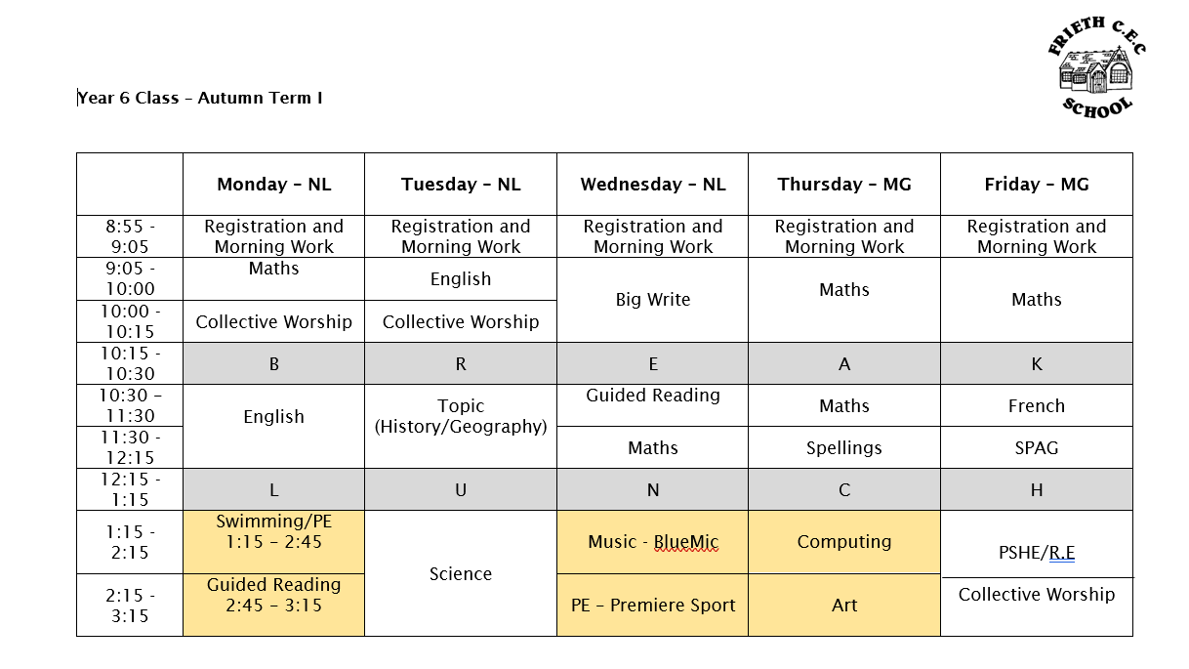

We are very much looking forward to the year ahead and working with your children. Please do not hesitate to contact us should you have any questions or queries.

Mrs Lampard Mr Gosling

