Resources for parents
- CEOP https://www.thinkuknow.co.uk/
- Kidscape https://www.kidscape.org.uk/advice/advice-for-parents-and-carers/internet-safety-and-addressing-online-risk/?gclid=CPTb6-yKu9UCFUK7GwodlSoLNw
- NSPCC This is a great source of support for parents. Think about adding this link to your website.
https://www.nspcc.org.uk/preventing-abuse/keeping-children-safe/online-safety/
- Parents Protect! -Project from The Lucy Faithfull Foundation. This site offers a roundup of a range of resources for parents including helpful guides to support parents where their child may have shared images on line
http://www.parentsprotect.co.uk/resources.htm
- “Digital Parenting” This is a Free magazine which can be obtained from Vodafone shops. You do not need to be a Vodafone user. It can also be accessed on line via the Parent zone they have created
https://parentzone.org.uk/projects/digital-parenting-magazine
Share Aware overview – Short
Share Aware, from NSPCC and O2, gives parents all the tools they need to have regular and informed conversations with their child about staying safe online. Under 20% of parents discuss online safety regularly with their children but we want to get every family talking about their child’s life online, just as they would their day at school.
Parents can sign up to the Icebreaker email series and become an expert in their child’s online world in 6 weeks, follow our four simple steps to keeping kids safe online, watch our film ‘Safety advice from a 10 year old’ or visit Net Aware – our guide to your child’s social networks apps and games.
The internet is a great place for kids to be, being Share Aware makes it safer.
- Just like in real life, kids need our help to stay safe online. Teach your child to be #ShareAware with @NSPCC and @O2 https://www.nspcc.org.uk/preventing-abuse/keeping-children-safe/share-aware/
- Teach your child to be #ShareAware online, with step-by-step advice from @NSPCC https://www.nspcc.org.uk/preventing-abuse/keeping-children-safe/share-aware/

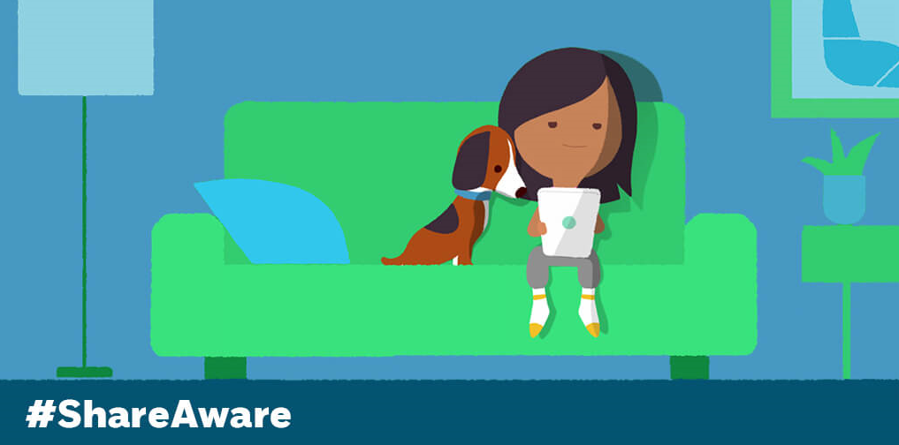

Share Aware campaign overview
To kids, online life is real life. And, just like in real life, kids need help to stay safe online.
Share Aware is an NSPCC and O2 campaign to help parents have regular and informed conversations with their child about online safety. We're aiming to get every family in the UK chatting about their kids' online world, just like they would about their day at school.
We tell children that’s it’s good to share, but online it’s different and sometimes it can be dangerous. Through our straight-forward, step-by-step advice and Icebreaker email series, we’ll show parents how to untangle the web and teach children how to make the right decisions online, even when parents aren’t there.
- Our new TV ad – Safety advice from a 10 year old.
- Icebreakers email series – We’ve teamed up with O2 to create a bespoke email series full of tips and information on different issues eg cyberbullying and inappropriate content, with activities parents can complete with their child.
- Mumsnet partnership – Join our Twitter Q&A at 12.30pm on 16th May using #ShareAware, alongside a Mumsnet Facebook live.
- Family agreements – We have created a downloadable family agreements document for families to complete and fill in together.
- Share Aware homepage - Read our step-by-step guide to being Share Aware and our TEAM (Talk, Explore, Manage, Agree) framework on how to stay safe online in four simple steps.
- Net Aware - Our guide to the most popular social networks sites, apps and games that children use. New sites site such as Musical.ly, Kiwi and Pokemon Go have been added this year, along with a breaking news page and top tips from O2 Gurus on blocking, private account settings or in-app purchases. The new Net Aware can be downloaded on both iOS and Android.
- Specialised advice - Advisors at our O2 & NSPCC Online Safety Helpline – 0808 800 5002 – are here to help with any questions, or anyone can make an appointment with a Guru in store.

