Prepositions
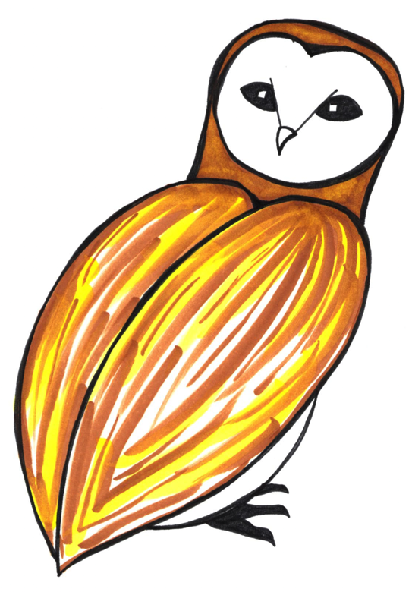
First read the sentence then re-write the sentence,
adding a prepositional phrase to add more detail
e.g. Hermione waved her wand.
Hermione waved her wand through the cold air.
Remember to underline the preposition you have used.

Harry raced.

Ron flew.

Hermione walked

Hagrid hid.

Draco pushed

Snape pointed his wand.

Now write three new sentences, each with a prepositional phrase.
Tuesday 16th - A

Prepositions
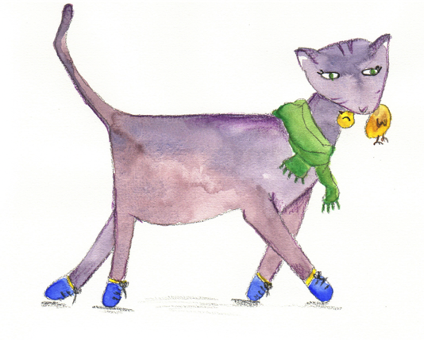
First read the sentence then re-write the sentence,
adding a prepositional phrase to add more detail
e.g. Hermione waved her wand.
Hermione waved her wand through the cold air.
Remember to underline the preposition you have used.
Add some of the phrases at the start of the sentence.

Harry dressed quickly.

There was a noise.

Hagrid stomped clumsily.

Draco laughed meanly.

Hermione held her breath.

Harry pulled on the cloak.

Now write three new sentences, each with a prepositional phrase at the start.
Tuesday 16th - B

List of Prepositions
Where

above below over between

inside on under outside into

When

before after in since

on during from at

Why or how

because of due to from

Tuesday 16th
Penguin Books
80 The Strand
London
WC2R 0RL

Reader’s Report on Harry Potter and the Philosopher’s Stone
Date read  13th June 1996 | Reader  Phyllida Stone | Number of words  77,023 words
Comments
This book is very fanciful. It describes life at a wizard’s school called Hogwarts and basically the plot revolves around wizards and witches. The book is too long. In my opinion, no child of eleven will get to the end.
Setting
The books starts on a street in a village, Little Whinging, but the plot mainly unfolds in the wizard school., Hogwarts I was not convinced by this setting. It is not explained how the school manages to hide itself from non- magical people (who the author calls ‘Muggles’) and, to my mind, it was all a bit too unlikely and far-fetched.
Characters
The main characters are three children: Harry, Ron and Hermione. This last character is not very attractive – she seems to be a show-off and too clever for her own good. The first character has tragedy in his past, but personally, I didn’t find him particularly appealing. I am not sure that many children would identify with his situation. Adult characters mainly consist of the teachers at the school and also Harry’s family who live in Little Whinging. These characters are a bit over the top as they are so nasty! Some of the teachers are quite funny but some are just plain silly, like a half giant who is supposed to be a gamekeeper living in a hut beside the forbidden forest.
Plot
The story seems to follow Harry’s struggle with an evil wizard, whose name is so scary that it cannot be said! I found this unconvincing. I thought the final fight was well-written but it was definitely too scary for children in Years 5 & 6, and the book is intended for this age-range. There are many side-stories and the author has unfortunately not stuck to the plot. The first part of the Harry’s story, which takes place at his aunt’s home, is way too long and boring and it would have been a lot better if the book had just started when Harry got to Hogwarts.
Recommendation  I do not believe that this book will sell many copies. It will only appeal to a small number of children. |  | Signed  Phyllida Stone
Wed 17th
Penguin Books
80 The Strand
London
WC2R 0RL

Reader’s Report on Harry Potter and the Philosopher’s Stone
Date read  13th June 1996 | Reader  Phyllida Stone | Number of words  77,023 words
Comments
This book is very fanciful. It describes life at a wizard’s school called Hogwarts and basically the plot revolves around wizards and witches. The book is too long. In my opinion, no child of eleven will get to the end.
where
Setting
The books starts on a street in a village, Little Whinging, but the plot mainly unfolds in the wizard school., Hogwarts I was not convinced by this setting. It is not explained how the school manages to hide itself from non- magical people (who the author calls ‘Muggles’) and, in my mind, it was all a bit too unlikely and far-fetched.
how
Characters
The main characters are three children: Harry, Ron and Hermione. This last character is not very attractive – she seems to be a show-off and too clever for her own good. The first character has tragedy in his past, but personally, I didn’t find him particularly appealing. I am not sure that many children would identify with his situation. Adult characters mainly consist of the teachers at the school and also Harry’s family who live in Little Whinging. These characters are a bit over the top as they are so nasty! Some of the teachers are quite funny but some are just plain silly, like a half giant who is supposed to be a gamekeeper living in a hut beside the forbidden forest.
Plot
The story seems to follow Harry’s struggle with an evil wizard, whose name is so scary that it cannot be said! I found this unconvincing. I thought the final fight was well-written but it was definitely too scary for children in Years 5 & 6, and the book is intended for this age-range. There are many side-stories and the author has unfortunately not stuck to the plot. The first part of the Harry’s story, which takes place at his aunt’s home, is way too long and boring and it would have been a lot better if the book had just started when Harry got to Hogwarts.
Recommendation  I do not believe that this book will sell many copies. It will only appeal to a small number of children. |  | Signed  Phyllida Stone

Quidditch Report

Identify the adverbs in each sentence
The 422nd World cup started spectacularly, with amazing fireworks.
Viktor Krum then flew skilfully around the arena.
The Bulgarian fans cheered loudly for their popular seeker.
The game began fast with both teams flying around the stadium.
Ireland scored promptly while Bulgaria played well.
Bulgaria grabbed the quaffle quickly and the teams were finally level.
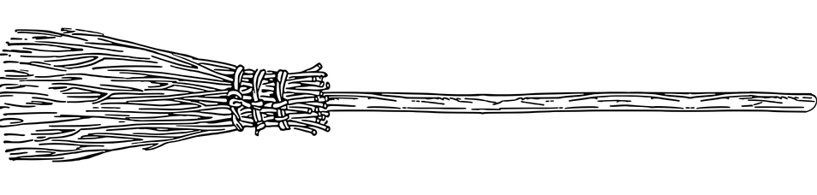
Modify these sentences by adding two new adverbs to each one
e.g. Viktor grabbed the Snitch. could become Victor grabbed the Snitch greedily /quickly /skilfully /tightly etc.

Victor grabbed the snitch.

The quaffle soared.

The Irish players celebrated.

Thurs 18th – A
Quidditch Report

Identify the adverbs in each sentence
The 422nd World cup started spectacularly, with amazing fireworks lighting up the sky.
The fireworks moved gracefully into the shape of the Irish mascot.
Viktor Krum then flew rapidly around the arena, showing off his skills.
The Bulgarian fans cheered loudly for their popular seeker.
The game began fast and both teams flew skilfully around the stadium.
The players had obviously practised earlier.
Ireland scored promptly while Bulgaria also played well.
The quaffle then soared above the crowds.
Bulgaria grabbed it quickly and the teams were almost level.
Modify and create two new sentences by adding different adverbs to each one
e.g. Viktor grabbed the Snitch. could become Victor grabbed the Snitch greedily /quickly /skilfully /tightly etc.
The quaffle soared.

Viktor captured the snitch.

Ireland won.

The Irish players celebrated.

Thurs 18th - B

Adverbs to choose from

almost awkwardly calmly rapidly perfectly

excitedly fast reluctantly wildly really

honestly easily defiantly well fortunately

unfortunately triumphantly skilfully yesterday

immediately nearly victoriously afterwards

cheerfully beforehand madly quietly

Thurs 18th

Quidditch Report - answers

Identify the adverbs in each sentence - easier
The 422nd World cup started spectacularly, with amazing fireworks.
Viktor Krum then flew skilfully around the arena.
The Bulgarian fans cheered loudly for their popular seeker.
The game began fast with both teams flying around the stadium.
Ireland scored promptly while Bulgaria played well.
Bulgaria grabbed the quaffle quickly and the teams were finally level.

Identify the adverbs in each sentence - harder
The 422nd World cup started spectacularly, with amazing fireworks lighting up the sky.
The fireworks moved gracefully into the shape of the Irish mascot.
Viktor Krum then flew rapidly around the arena, showing off his skills.
The Bulgarian fans cheered loudly for their popular seeker.
The game began fast and both teams flew skilfully around the stadium.
The players had obviously practised earlier.
Ireland scored promptly while Bulgaria also played well.
The quaffle then soared above the crowds.
Bulgaria grabbed it quickly and the teams were almost level.

Thurs 18th – A

Health and Safety Report

Name of inspector: | Date of inspection:
Overall rating of safety: /10
Will you allow the school to continue to play Quidditch?

Fri 19th

