Week beginning Monday 27th April 2020
Welcome to the Frieth Y3 and Y4 French home learning page!

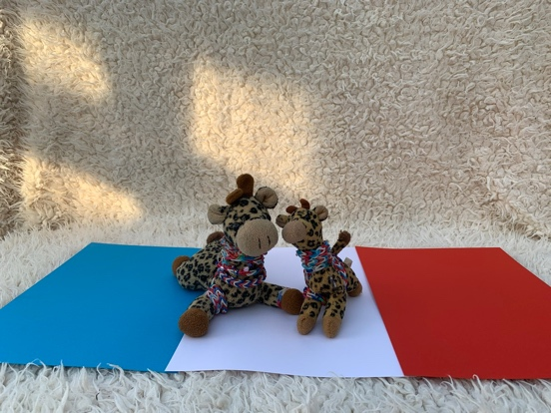

Last week I asked you to ask a grown up in your family to subscribe to High Five Languages, a free online language resource so that we can use lots of their activities each week. In case you did not manage it with the link I shared, here is another one which should take you straight into the free subscription page:
https://rlneducation.com/p/high-five-french-schools-3months

- Watch video lesson 2 – you can revise how to say your name and ask someone else what they are called in a variety of ways. The video clips are so short, they are a brilliant way of keeping all the language we have done, fresh in your memory!
- You will see ‘Activity Sheets’ in the contents list. Try both worksheets for Lesson 2.
- Again, feel free to explore everything in the contents list for lesson 2 – whenever you have time – even the Teacher’s notes if you want to - I suggest the Vocabulary list – it is like a mini dictionary.

1.

- So many people seemed to enjoy the football biscuits recipe last week (merci beaucoup for the photos!) that I have another recipe for you to try. If you click on the YouTube link below, you will meet a young boy called Charles. His mum is French. Charles is learning two languages so he will become bilingual. Together they are preparing a super fruit smoothie. Miam miam! (What do you think this means?)

https://youtu.be/9dRYRfcrbOs

Maybe you can take some photographs of your delicious smoothie…

Bon appétit!

2.

After all that hard work, you might like something a little more relaxing. If you click on the link below, you will find a calming, mindfulness activity, en français

https://youtu.be/mkQsUmlcrng

3.

