Kites Class Year 4
Day | Maths | English | Other
Mon 8.6.20 | Please then go to WHITE ROSE Planning for Week 6 of The Summer Term and follow Lesson 1.  On their website this is marked wc 1.6.20 SUMMER TERM WEEK 6  https://whiterosemaths.com/homelearning/year-4/  LOOK FOR THE WORKSHEETS AND THE ANSWERS IN THE MATHS BLOCK ON OUR CLASS PAGE | Spelling This week you are looking at words with the suffix ous (with no definitive root word).  tremendous  enormous  jealous  serious  hideous  fabulous  curious  anxious  I have attached the Year 4 Spelling A4 Poster  Look through the power point presentation. It will help you understand the spelling pattern.  Then complete your workbook - spelling booklet 3B week 2  Challenge – Do the Crossword activity.  Handwriting – Practise writing the words using a cursive script.  Open the Handwriting sheets | Frieth School Vision pupil and parent consultation.  Mrs Reid has asked for all of you to do this activity.  See the document that is attached to the class page. You will need the help of an adult.
Tues  9.6.20 | Please then go to WHITE ROSE Planning for Week 6 of The Summer Term and follow Lesson 1.  On their website this is marked wc 1.6.20 SUMMER TERM WEEK 6  https://whiterosemaths.com/homelearning/year-4/  LOOK FOR THE WORKSHEETS AND THE ANSWERS IN THE MATHS BLOCK ON OUR CLASS PAGE | Reading –  I was really impressed with the reading test results from last week’s work on Education City. Well done. Today you are going to learn about using inference.  Go to this link  https://www.bbc.co.uk/bitesize/articles/zf7qmfr  LO To understand what inference means and use it to answer questions about a story.  This lesson includes:  - one video to remind you what inference is  - one video telling the story of Tiddalik the Frog  - three activities | SCIENCE – FOOD CHAINS  Check EDUCATION CITY for a series of activities on FOOD CHAINS  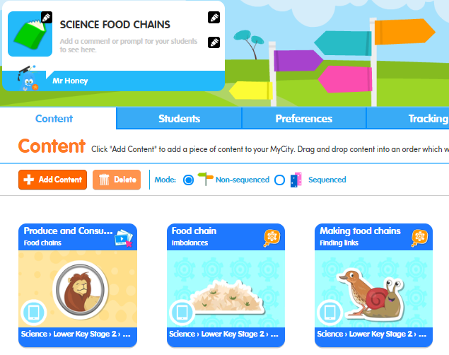  You could also look at the excellent clips that are to be found on BBC Bitesize  https://www.bbc.co.uk/bitesize/topics/zbnnb9q/articles/zwbtxsg  … and have a look at the Power Point and the Food Chain Challenge and Sorting Cards you’ll see in the resources on our class page.
Wed  10.6.20 | Please then go to WHITE ROSE Planning for Week 6 of The Summer Term and follow Lesson 1.  On their website this is marked wc 1.6.20 SUMMER TERM WEEK 6  https://whiterosemaths.com/homelearning/year-4/  LOOK FOR THE WORKSHEETS AND THE ANSWERS IN THE MATHS BLOCK ON OUR CLASS PAGE  . | Grammar  Well done to those of you who did the test last week on Education City. There are still some of you who have not completed it, so please try to before the end of this week.  Today for grammar you are going to revise apostrophes for possession  https://www.bbc.co.uk/bitesize/articles/znyf382  This lesson contains:  - one video to help you revise how to use apostrophes to show possession  - one video showing the first episode of Treasure Island  - four activities | FRENCH  Look in the resources on the class page and find your activity from Madame Reynard. You’ll see that see’s done different activities for Y4 and Y5 so make sure you chose the correct one. BTW Monsieur Miel’s on line French lessons have been going very well. I’ve got a 90 day streak now!!
Thurs  11.6.20 | Please then go to WHITE ROSE Planning for Week 6 of The Summer Term and follow Lesson 1.  On their website this is marked wc 1.6.20 SUMMER TERM WEEK 6  https://whiterosemaths.com/homelearning/year-4/  LOOK FOR THE WORKSHEETS AND THE ANSWERS IN THE MATHS BLOCK ON OUR CLASS PAGE | Writing LO To choose words and phrases that capture the reader’s interest  Over the next two weeks we are going to be looking at some poetry inspired by Ancient Greece.  Look at the Power point and listen to the video I have done where I am reading 3 different types of text. Could you identify how they are different?  Task 1  Read the poem about an Ancient Greek temple on the power point.  Could you identify the different parts of the temple being described in the poem?  i.e. columns, statues, frieze etc.  What type of words helped you to be able to do this?  Suggest other words that could have been used in the poem to describe the different parts of the temple.  Write a list of your suggested words down.  Identify the most powerful vocabulary to help describe each part.  Now I want you to suggest better alternatives for some of the weaker vocabulary.  Task 2  We can use adverbs to help describe verbs and adjectives to help describe nouns.  Spot examples of each word class in the poem. Underline the adverbs, verbs, adjectives and nouns in different colours. Identify adverbs that can be used to help describe each verb and extra adjectives to help describe each of the nouns.  I now want you to take the poem and up level it using better adverbs and adjectives. You could us a thesaurus to help you.  Main task  Look at the poems about Greek gods (4 line stanzas that rhyme)  Do you think they are good? I think that they could be improved.  Write one of your own 4 line stanza, ensuring that the vocab is strong.  You could record you performing this and send it in to me.  . | COMPUTING – ONLINE SAFETY  Awareness of online safety has probably never been more important for children of all ages (Mr Honey included) and lock down has seen many reports of increases in on line fraud. Here are a series of 15 minute exercises from THINKUKNOW who work with CEOP to support your learning in this important area. I suggest you have a look at a the first two but by all means explore the others if you’d like to.  https://www.thinkuknow.co.uk/parents/Support-tools/home-activity-worksheets/8-10s/?utm_source=Thinkuknow&utm_campaign=6647114059-TUK_ONLINE_SAFETY_AT_HOME_02_06_20&utm_medium=email&utm_term=0_0b54505554-6647114059-55006529
Fri  12.6.20 | Look in EDUCATION CITY for the activities on solving word problems in maths. | Writing LO To be able to use expanded noun phrases  Look at the power point for Friday whilst you read this.  I want you to think about some of the gods and goddesses that were worshipped in Ancient Greece.  What can you tell me about them?  The Ancient Greeks built temples to honour the gods. What decorations might particular gods have? (eg; lightning bolts)  When you read the poem Greek Gods on the power point (It is also attached as a word document) how were you able to identify the Zeus from the description in the poem?  Why were particular words chosen to describe each part of the temple?  Identify weak vocabulary in the poem and suggest more powerful alternatives.  Task 2  Looking at the poem Greek Gods identify words that can be used to describe the temple from the poem to match each of these headings: feelings, sights, actions, sounds and colours.  Put the words under these headings.  Task 3  Put the words together from the feelings, sights, actions, sounds and colours to create descriptive phrases to help describe the chosen location i.e. silver shimmering statues, magnificent marble columns etc.  Write these phrases down.  Now look at the sentences on the Power point and improve them.  - Two heavy statues.  - Lots of crooked steps.  c) Enormous golden throne.  d) Beautiful stony mosaic.  Task 3  Use the Greek Gods tables sheet and choose a couple of Gods that you are going to work on. Add the adjectives, nouns and verbs. Try to do up to 10 lines for this. Keep all this work as you will be using it to help you write your poem next week.  Task 4  Identify one wow adjective and one ordinary adjective to add to each sentence to describe the temple.  a) Zeus’ temple was on the hill.  b) The statue was at the front of the temple.  c) A throne was next to the entrance.  d) Pictures had been carved into the floor.  e) The steps were made from marble.  f) People can sit around the fountain.  Look at the different parts of a temple. We call these words nouns. Think of some powerful adjectives that can be used to help describe each noun.  Next week we will look at how to group together sets of words to begin describing the temple to create lines in a poem by combining nouns with verbs and adjectives | SPORTS DAY  As it was supposed to be Sports Day at school today we thought it would be fun if you tried to organise your own “Sports Day at Home” and there is a set of resources to do this in this week’s resources which you can choose from or you may have your own even better ideas. It would be great to see some photos!!

