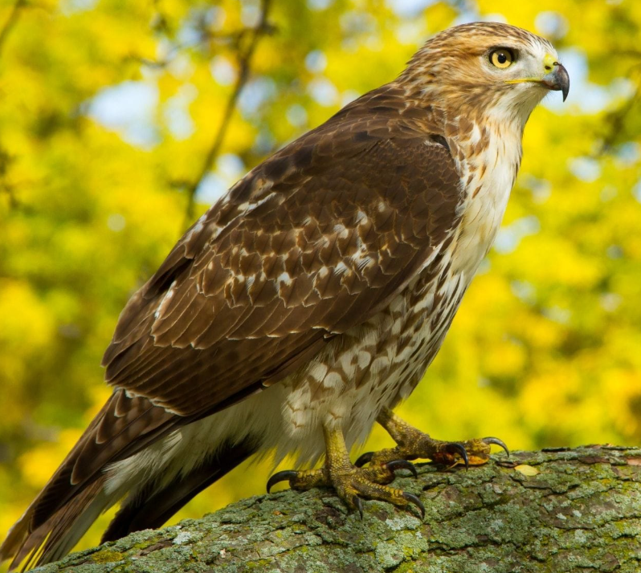

Hawks Curriculum Information

Autumn Term 2025

Hello and welcome to the new school year! For those of you new to Hawks class, I’d like to take this opportunity to introduce myself; my name is Miss Rackstraw, and I will be teaching your children this year. We have an exciting time ahead of us, filled with lots of different activities and opportunities; I look forward to participating in these with both the Hawks class children and you, their parents and carers. This year, Hawks will be taught by myself on Mondays, Tuesdays, Thursdays and Fridays. Ms Crowther will be taking the class on Wednesdays.

Over the course of this term, our over-arching topics will be ‘Anglo-Saxons’ and ‘All Around the World’, which will both be taught creatively across the curriculum.

English
The English programme of study is divided into three core units of Narrative, Non-Fiction and Poetry. These are studied in a variety of ways throughout the year. We have already started this half term’s class text, Beowulf. We will use this text as a basis to generate and inspire written work across all three core units of writing.

At home, children should be reading independently or to an adult every night. To encourage this, children have a ‘Reading Record’ to log their daily reading activity. This must be brought into school every day.

There will continue to be a significant focus on Spelling, Punctuation and Grammar (SPaG) with whole class Guided Reading sessions timetabled on a regular basis; it is during this time that we will be reading our class text.

Maths
The different areas of the National Curriculum will be covered over the year, incorporating prior learning, and extending and challenging all of the children. This term we are revising and developing our understanding of place value, the four number operations and measures. We will be using a range of resources to do this, including White Rose, Power Maths and Classroom Secrets. These resources are excellent in developing the fluency, reasoning and problem-solving skills necessary to be proficient in the Year 4 and 5 curriculums.

Science
Over the course of this term, we will be looking at ‘Living Things in their Habitats’ and ‘Electricity’ as our science topics.

In our topic on living things, we will look at the shared characteristics of all living things, how they can be grouped and sorted and how classification keys can help to organise this. We will be using our knowledge to identify living things from within our local environment. This will include a trip to the Lady Ryder Memorial Garden on the 13th of October.

In our topic on electricity, the children will learn about common electrical appliances and how to construct simple series circuits. They will become familiar with the key words linked to the topic and how to apply them appropriately. Children will learn about cells, wires, bulbs and buzzers and about the different types of switches. They will be able to troubleshoot and identify whether or not a bulb will light in a simple series circuit and be able to identify a complete circuit. The children will also learn about conductors and insulators and know that metals are very good electrical conductors.

R.E.
In the first half of term, the children will be learning all about Hinduism and considering the question: Do Murtis help Hindus understand God?

During the second half of term, the children will be thinking about the Christmas narrative and considering whether Mary needs to be a feature within it.

History
For the first half of the autumn term, we will be learning about the Anglo-Saxons. We will find out where the invading troops came from and where in Britain they managed to settle and then we will go on to investigate how life in Britain changed as a result. The children will have the opportunity to learn how the Anglo-Saxons influenced the English language, with an emphasis on the origins of some English place names, and they will also examine and analyse artefacts from the period and draw their own conclusions about what they can teach us about life in Anglo-Saxon Britain. In addition to this they will also learn what life was like in a typical Anglo-Saxon village, what jobs people did and what the houses were like. They will also explore the Pagan beliefs of the early Anglo-Saxons and learn about the many gods they worshipped. Finally, they will investigate how and why the Anglo-Saxons were largely converted to Christianity by the early 7th century.

Geography
Our ‘All Around the World’ topic allows children to take a closer look at where the countries of the world are located, and some of the ways geographers describe locations. Children will learn to locate and describe places using longitude and latitude and find out about some of the important lines that delineate specific areas of the Earth - the Equator, the Hemispheres, the Poles and the Tropics. Finally, by looking more closely at the lines of longitude, children will develop their understanding of time zones.

Computing
Our focus in computing will be around online safety, where children will learn about preventing and dealing with cyberbullying and using technology safely and responsibly; how to use search engines efficiently; how to identify a range of ways to report concerns; and how to be a good digital citizen. The unit ends with children applying their new knowledge to design a character to be displayed around school to promote online safety.

French
French will be taught by Miss Crowther. In French, the children are studying the unit ‘Je me présente' (Presenting Myself). They will learn how to: count to 20 in French; ask somebody how they are feeling and give an appropriate response back; ask somebody their age, name, where they live and reply.

Music
In year 4, we will be learning more complex musical notation. We will look at challenging time signatures, ledger lines, Accidentals, Key signatures, Quavers, Semiquavers and equivalent rests We will also look at Dotted notes and ties. We will be using our keyboards to perform what we have learnt, practicing lots of different songs that are written in musical notation.

Art

In Art, we will be completing a unit on drawing, focussing on developing our analytical and observational skills, using patterning in natural objects to create landscapes. We will use the work of John Brunsdon as sources of inspiration for our own drawing development.

In our second unit, which will be on painting, we will look at the work of Georgia O’Keefe and Turner to develop our technique and use of tools, textures and painting materials.

Design and Technology
To complement our Anglo-Saxon topic, children will have the opportunity to develop their sewing skills to create their own version of a section of the Bayeux Tapestry.

P.E.
During the Autumn term, Hawks class will be doing gymnastics on a Tuesday afternoon. On Wednesday afternoons they will be doing invasion games outside with Premier Sport, after half term this will change to Forest School. It is essential that your child has their correct PE kit in school, we will be bringing them in at the start of each term, to then stay in school until half term.

P.S.H.E.
For this term our theme is ‘Relationships.’ As part of this the class will explore the different types of relationships that we have. It will look at friendships, how friendships are formed and maintained, and the qualities of a good friend. The lessons will then move on to disputes and bullying and will address strategies for coping with each of these.

Forest School
Forest School will start after half term on a Wednesday afternoon; Hawks class will be looking at ‘Living Things and Their Habitats’ by discussing living creatures and their habitats in the Forest School space and classifying vertebrates and invertebrates. They will also be looking at the Anglo- Saxons and discovering how early civilisations manipulated natural materials in everyday objects by practicing whittling sticks.

Weekly timetable

Below are the planned weekly timetables for Hawks class. Please note, however, that there will be variations to this timetable as necessary.

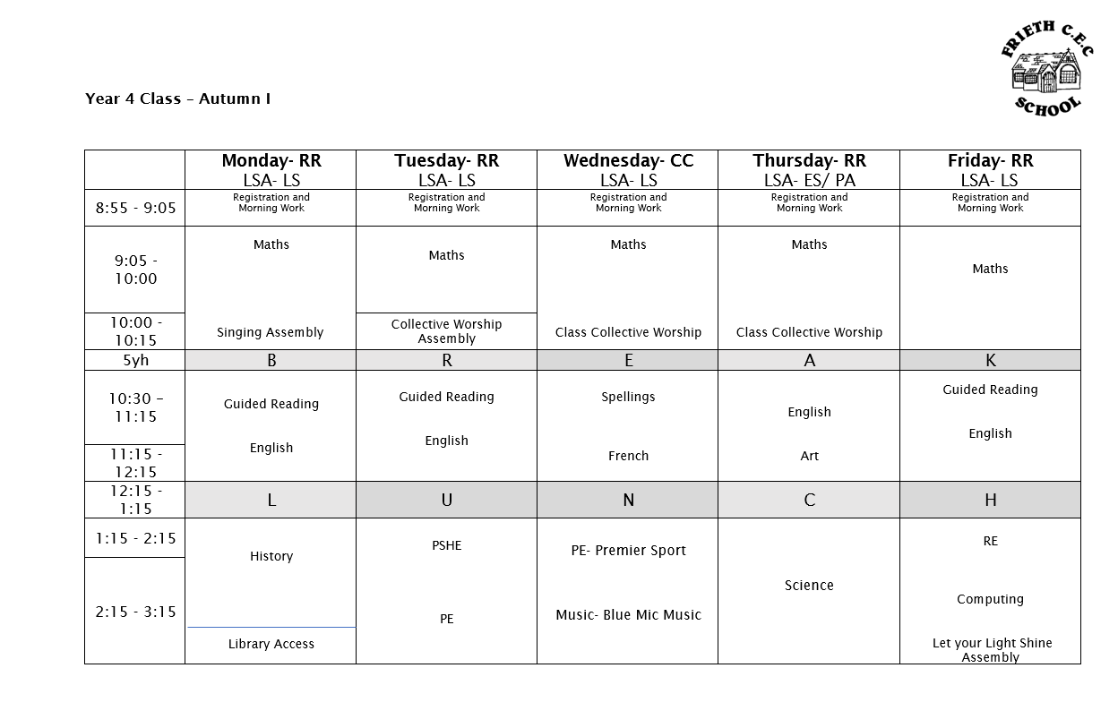
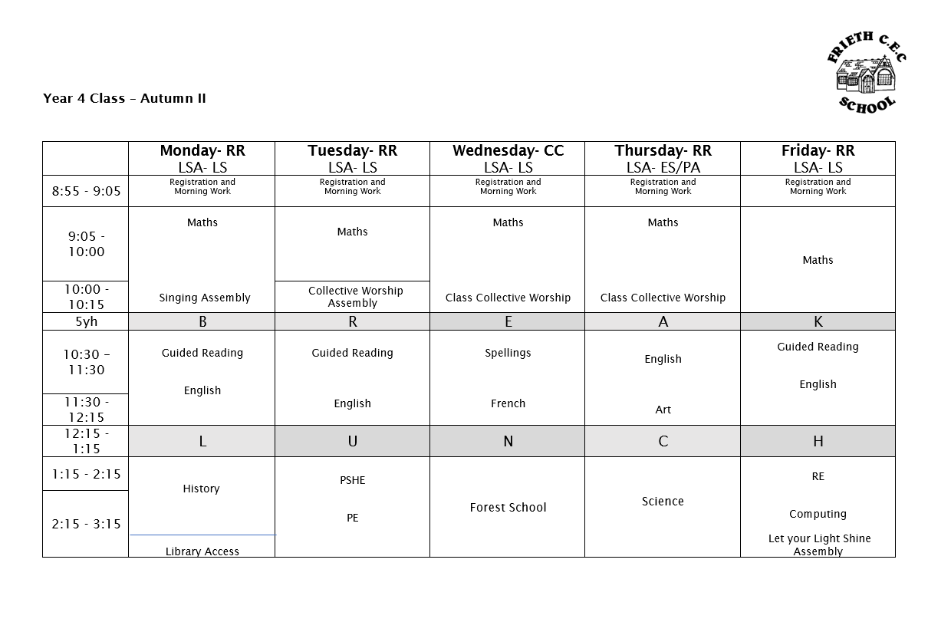

I am really looking forward to the coming year and working with your children. If, at any point, you have any questions or queries, please do not hesitate to contact me.

Miss R Rackstraw
RRackstraw@friethschool.co.uk

