French home learning Monday 1st June 2020 Y3 and Y4
(Some children wanted just a little French for the half-term holiday so they will have seen some of the activities below already.)

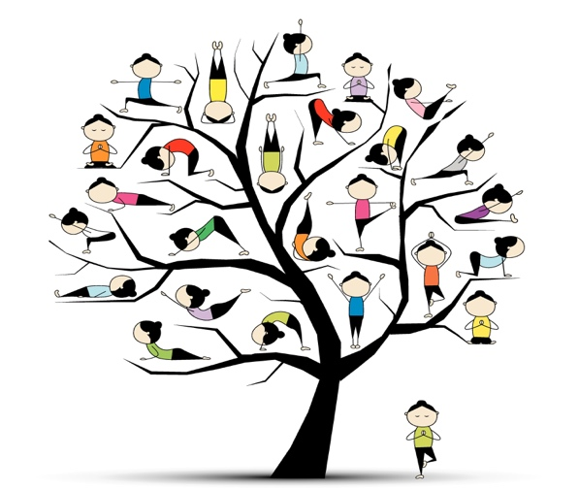
This Photo by Unknown Author is licensed under CC BY-NC-ND
As you can see from the picture above, this week is all about relaxing! Afterall, it is so hot outside!

Click on the link below for some Froga with my friend Madame Cantin.

https://youtu.be/2wcF_MoCfeM

Instead of watching High Five this week, I would like to introduce you to Monsieur Innes. He loves French! Just to refresh your memory about ‘Les couleurs’ and how to pronounce them correctly, click on the link below. Watch out for the new colour that he introduces to you…..

https://youtu.be/LleqCDOoaZM

Do you remember the new colour? Indigo pronounced an-dee-go
Don’t forget that en français, ‘in’ sounds more like ‘an’

Can you spot which colour is missing? - - - -

Complete the grid. I have done the first one for you
1.bleu | = neuf | 4.rose | = | 7.jaune | = | 10.marron | =
2.blanc | = | 5.violet | = | 8.indigo | = | 11.vert | =
3.rouge | = | 6.gris | = | 9.noir | = | 12.orange | =

So many of you have enjoyed the French recipes that I thought you would like this one, although it is a little naughty! It’s called, “Chocoloate spoons.” They are delicious with some ice-cream!

I am sure you will be able to follow the recipe by looking at the pictures, but don’t forget your bilingual dictionary if you have one – or click on the link to the online one.

https://www.collinsdictionary.com/dictionary/english-french
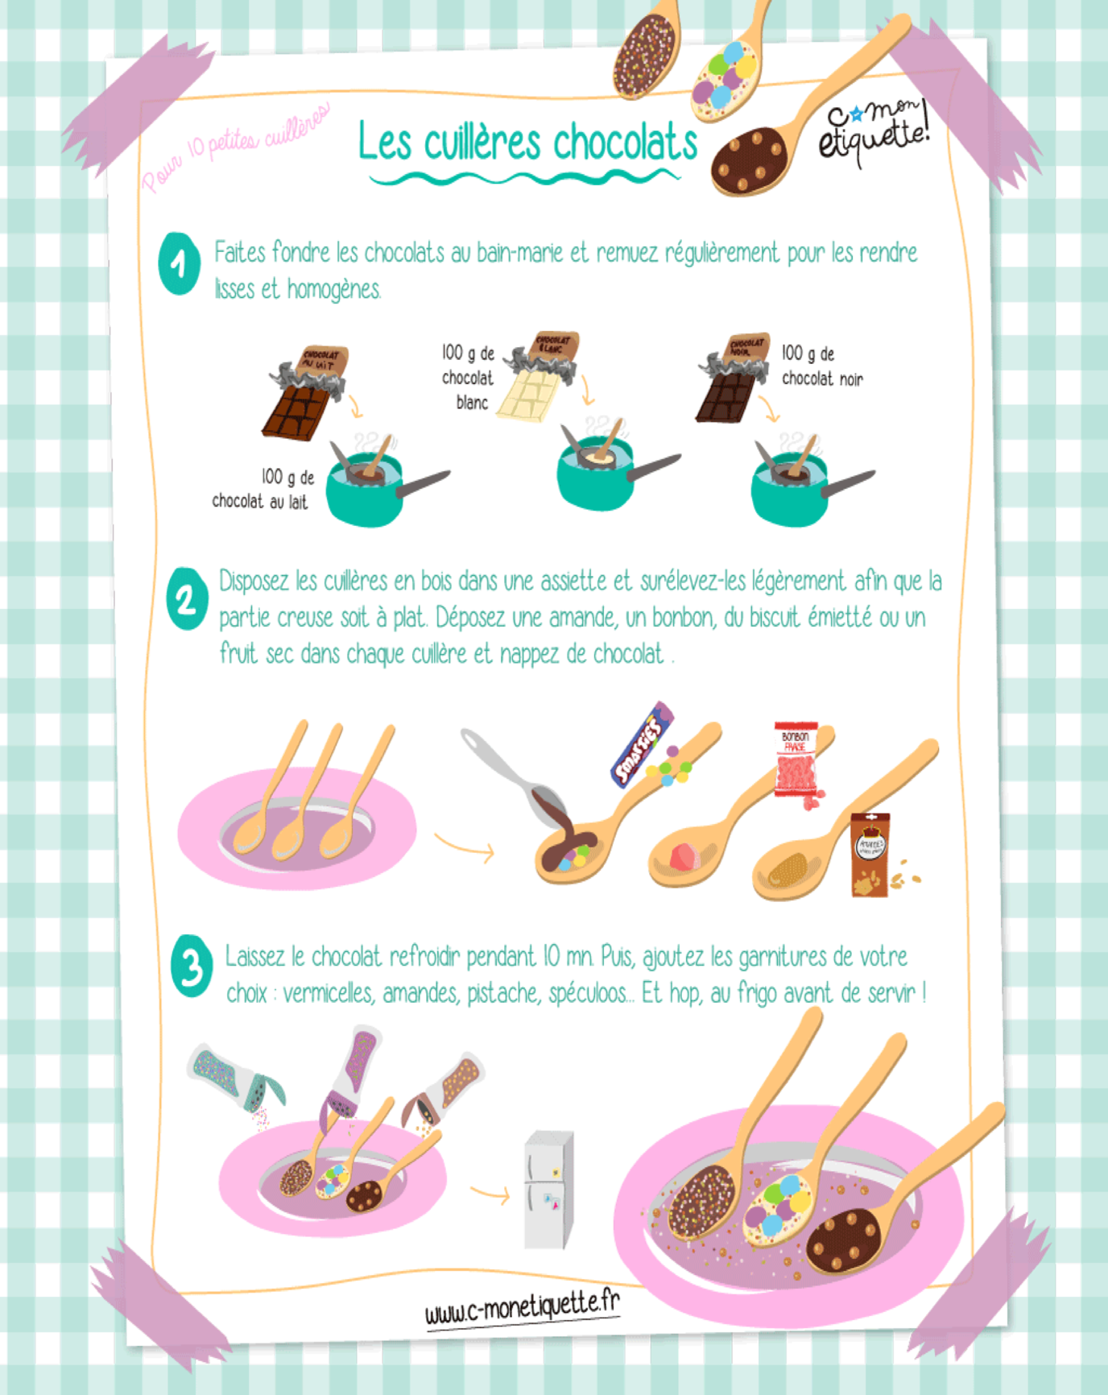

*As always, be sure to work with an adult when preparing something hot!*

