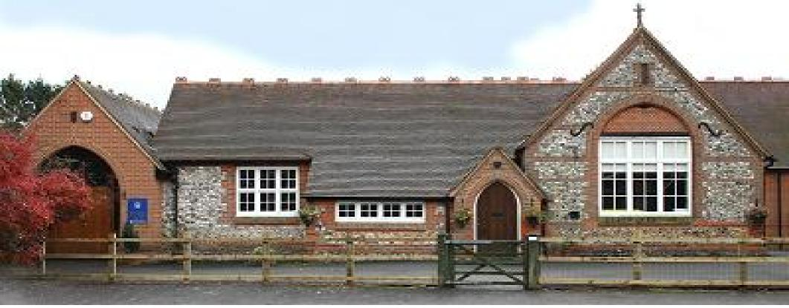
Frieth CEC School PTA
Meeting Minutes

26th September 2018

Present: | Juliette Cheung (JC) | Bertie Bayliss (BB) | Lisa Martin (LM)
Richard Peircy (RP) | Leah Cubbage | Jennie Batt | Kate Jones
Fi Hayter | Jo Reid (HR) | Sarah Hunt | Katrina Ashcroft
Anya Lautenbach

Apologies: | Katherine Cox | Sarah Tedder (ST) | Denise
Sophie Charlesworth | Charlie Lumley

Your class/parent reps are

Owls Jess Coombs coombesmarlow@gmail.com
Buzzards Courtney Ainsworth courtneybrennan@btinternet.com
Kestrals Lorna O’Hehir theofamily@icloud.com
Kites Fiona Hayter fi.hayter@btopenworld.com
Eagles Sarah Tedder jackjackwalk@icloud.com

At the beginning of each term, the class teacher will contact the Class Rep with information about the term ahead. The parent Class Reps meet each half term with Mrs Reid to discuss any points on your behalf; they will let you know in advance when a meeting is coming up. Your Rep will remind you of calendar events such as assemblies, non-uniform days etc.

You can ask your Rep questions about the class/school and they will do their best to answer, or get an answer from the Rep meeting or class teacher; this saves many people contacting the school about the same issue.

Please remember if you have any questions or issues with the class routine or upcoming events in the classroom, these can be addressed by asking the Class Rep to approach the class teacher for information. Any questions or issues about your child as an individual, it is better to contact the class teacher directly via the office.

What is Curriculum Enhancement? Curriculum Enhancement is anything that enhances our children’s time at Frieth CEC School.

All PTA events are organised to raise funds for Curriculum Enhancement; IT, library, reading books, kitchen, outside area, school trips, visitors to the school, playground equipment, playground markings, picnic benches, etc. All this will enhance our children’s learning and time at the school.

Agenda item | Actions
- Welcome

BB welcomed all attendees. Apologies were noted.

- Accounts  Accounts reviewed: -  Main Account Balance £9,460.81  Minus Hilly funds received £1,843.00  Total £7,617.81  100 club account current balance - £1,141.04.  Costs still to be accounted for: - Praise in the Park Coaches  Bank Signatories need to be updated.  This account is used as a savings account and winning numbers come from the main account. | LC
- 100 Club Draw

Draw for Sept carried out during meeting – No 37.

JC subscribed and paid £20.

- Previous Events – updates and evaluation

Please forward any feedback to the PTA.

BIG thank you to everyone who helped arrange and run the events.

Events discussed: -

- Disco - £131.93 - DJ charged £90
- Summer Queen - £602.39 – Well received.
- Camp Night – Raised £605.85
- Sports Day – feedback – Generally positive feedback on new Club Sport format. Although it was mentioned that it’s difficult if you have more than one child. A suggestion for the PTA to provide tea/coffee next year.
- New Parents PTA Lunch – need to condense timings so that parents are waiting for the lunch. Risk of them leaving before hand.

- Future Events  - General - Allocation of events per class for the year – see Events 2018/2019 attached.  - Welcome Parents Event – Sept 18 – update – potential move to 2nd Nov.  - Frieth Hilly - 7th Oct – request for volunteers for the bacon baguette stall. SH offered to help and provide extension cable for refreshments area. PTA to buy new power cable.  - Table Top Sale – 14th Oct – more tables need to be sold.  - Disco – 9th Nov Jess Jonzen managing this event.  - Film Nights – Sarah Tedder to provide more dates.  - Long Distance Cycling Event – RP and Jess C working on proposal.  - Christmas Fair – 24th November - request for volunteers. PTA to arrange initial planning meeting.  - May Ball – Update – Venues need to be investigated.  - Camp Night – JC to check with Mr Cheung date of Cub Camp to ensure it doesn’t clash.  Help put the fun in fundraising and let the PTA know if you have any ideas! | SH  ST  RC/JCo  PTA  May Ball Team  JC
- School Updates/Requests

- Outside Area Development Update – Phase 1 and 2 to be completed before Hilly. Phase 3 by the end of this term.

- New Curtains for the Hall – must go through Premises Committee for Health and safety, fire retardant. Prem. Committee meeting after the Hilly.

- PTA Committee Profile Updates – Mrs R to update website.

- Newsletter - now 2-weekly.

- Any other business  - Father Christmas gift – Katrina Ashcroft to investigate alternative to chocolate selection box with same budget constraints.  - Family Photo Shoot – Mrs R to speak to parent who’s a photographer.  - Wreath Making Class – Anya Lautenbach has offered to hold a small class. Date proposed Wed 28th Nov.  - Drama Club – going ahead.  - Notice Board Outside School – KA will arrange for the Boards to be attached to the fence.  - PTA Email Address - PTA@frieth.sch.uk – LM to monitor on behalf of PTA. | KA  Mrs R  AL  KA  LM
Notices/Reminders
- Match funding – some companies offer match funding. Is there anyone in the school whose company will support fund matching? Contact the PTA if your company supports this.
- When dropping off in the mornings please don’t park outside the Village Hall this is where the bus stops and for those using the turning circle need the space. If you are dropping off a child that needs assistance to exit the car or your car only has 2 doors please park and walk the child to the gate. Please pass this on to any child-minders and grandparents who might not know.
- Collecting at the end of the day please don’t block residents’ driveways and leave extra space for the minibuses to be able to turn out of the school drive.
Date of next meeting: After Half Term - TBC

