Kestrels Blended learning Timetable 29-06-2020
Day | English | Maths | Topic area
Monday | Spelling Term 3B week 5 | Yr3: Draw accurately  Yr4: Interpret charts | PSHE lockdown
Tuesday | Reading play script and activities | Yr3: Recognise 2D shapes  Yr4: Comparison, sum and difference | Art mask making
Wednesday | BBC bitesize recounts | Yr3: Recognise 3D shapes  Yr4: Introducing line graphs | Topic Ancient Greeks
Thursday | BBC Bitesize how to write a play | Yr3: Telling the time to 5 minute intervals  Yr4:Line graphs | Science
Friday | Write own play script | Yr3: Classroom secret 3D shapes  Yr4: Activities on graphing discovery education | RE Moral choice
Extra leaning | Read rest of play script  Purple Mash Todo reading chapter book and activities  Sir Linkalot spellings | TT Rockstars  Mathletics  Education city games  Kids classroom secrets | Mindfulness activities  Science challenges (found on web site under class pages called science pupil page)  PE sport activities

Yellow shows home learning before coming into school for afternoon session as well as Friday and extra home learning activities.
Green shows learning that will take place in school during afternoon session.
For those working at home only you can do the activities in any order by picking and choosing what you do when as before.
Day by day timetables for Monday to Thursday with individual detail of lesson content are below.
For those in key worker group, who are in all day, there are suggested activities for your extra sessions.

Monday 29th June 2020

Year 3:  Watch the White Rose video https://vimeo.com/432264831 on drawing accurately.  Complete worksheets for Monday lesson 1.  Extension task: Discovery education using measures to find perimeter of shapes https://central.espresso.co.uk/espresso/modules/m2_maths_mansion/ttd/ttd_around_outside.html  I have put a hard copy of the sheet on the class page if you can’t access the site. Can you draw these or your own shapes accurately to prove perimeter is correct? |  |  | PSHE  Take a look at these worksheets on the class page about lockdown positives. They are all about helping you think positively and recognising all the good things that you have done, new skills you may have learnt or things you have found about yourself.  - What questions you have about returning to school? (for those children returning to school on Monday 28th June).  - Summary of time away from school  - What positives have come from lockdown.
Year 4:
Watch the video from White Rose https://vimeo.com/432265268 on how to interpret charts.
Complete the worksheets for Monday lesson 1

Extension Nrich problem on interpreting data in different ways. Match the Match https://nrich.maths.org/4937
Home learning morning session. | Spelling: Please go to your spelling booklet 3B and complete week 5.  Year 3 are looking at silent letters revision.  Year 4 are looking at adverbials of frequency and possibility.  Look through the powerpoint presentation from the web page to help you understand the spelling patterns then complete your workbook.  I have also attached the wordsearch, handwriting sheet and another activity for you to do as well should you wish to have a go.
Extra Activities Key Workers |  | Mindfulness booklet or drawing.

Tuesday 30th June 2020

English  Today I want you to enjoy some reading and complete activities related to it. I have put on the class page the first part of a play script called ‘Beauty Is a Beast’.  Read through and complete the activities shown.  As an extension I have put the rest of the script online. You can read through this and just enjoy the story.  Think about the characters personalities and how they are shown through the script. You will be writing your own play script on Friday. |  |  | Art  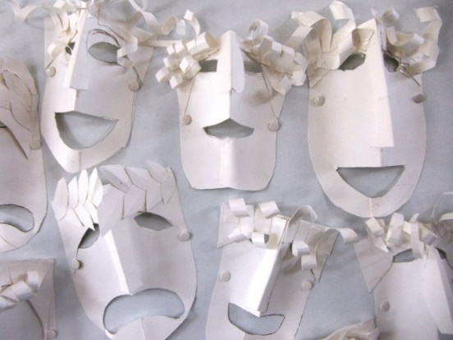  This week I would like you to make your own mask.  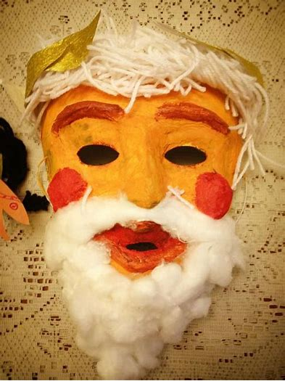  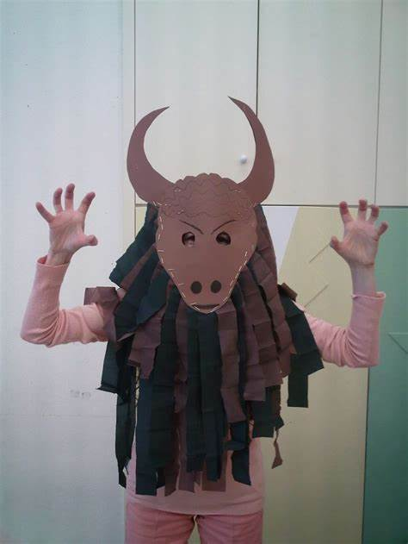  Look on the class page for some further information and examples of masks used in Ancient Greece. They can be made from any materials. Send me some pictures so I can see how amazing they look.
Home learning morning session. | Year 3 Maths: Watch the White Rose video https://vimeo.com/432264925 on recognising and describing 2D shapes.  Complete the worksheets for Tuesday lesson 2  Extra activity: Discovery expresso sort 2D shapes according to their properties https://central.espresso.co.uk/espresso/primary_uk/subject/module/activity/item612729/grade1/module883106/index.html  Extension task: Go to Discovery education and take the challenge on drawing 2D shapes. You will need a ruler for this! https://central.espresso.co.uk/espresso/primary_uk/servlet/file/store66/item373089/doc.pdf  I have also put a hard copy of the sheet online if you can’t access the site.
Year 4 Maths: Watch the video https://vimeo.com/432265829 on comparison, sum and difference.
Complete the worksheets provided for Tuesday lesson 2

Extension: Discovery education 2 quizzes to test your knowledge of converting measures, adding and finding the difference 1. Measures https://central.espresso.co.uk/espresso/primary_uk/standalone/activity_html/item230528/index.html
2. Mass
https://central.espresso.co.uk/espresso/primary_uk/subject/module/activity/item631303/grade2/module660072/collection660565/section660674/index.html
Extra Activities Key Workers |  | Woodland Trust creative activity. See the link with details of the activity https://www.woodlandtrust.org.uk/support-us/act/your-school/green-tree-schools-award/woodland-words-and-images/ and the instruction document on the science pupils page.

Wednesday 1st July 2020

Year 3:  Watch the White Rose video https://vimeo.com/432265088 on recognising and describing 3D shapes.  Complete the worksheets for Wednesday lesson 3  Extra activity: Discovery expresso, sort 3D shapes according to their properties https://central.espresso.co.uk/espresso/primary_uk/subject/module/activity/item613016/grade1/module883106/index.html  Extension task: Discovery education- shape properties quiz https://central.espresso.co.uk/espresso/primary_uk/subject/module/activity/item533674/grade2/module326792/index.html |  |  | English:  Go to the BBC bitesize page and complete activities on how to write a recount. I have put a copy of the activity sheet connected to this on the class page but everything should be available on the site.  https://www.bbc.co.uk/bitesize/articles/zkpvbdm What is a Recount?  Activity sheet is Christine Ohuruogu recount how she became a top athlete.
Year 4:
Watch the video https://vimeo.com/432265995 introducing line graphs.
Complete the worksheets provided for Wednesday lesson 3.

Extension: Go to the class page and find the worksheet on line graphs from classroom secrets. You have to interpret the graphs and match to events.
Home learning morning session. | Topic:  This week I would like you to do a research project on the Ancient Greek Theatre.  On the class page you will find several links to the theatre and some images for you to look at.  I would like you to do your own research either from the given information or your own found information from books, web searches etc. Please make sure you are being safe when searching sites on the web pages and have an adult around if you can.  You can present your work in any way you like to tell others about the Greek theatre such as a poster, presentation on the computer, written piece or fact file. See if you can use some of your computing skills to complete this task.
Extra Activities Key Workers |  | Join Jo Wicks for some exercise and PE fun.

Thursday 2nd July 2020

English:  Go to the BBC bitesize page. Today we are looking at the features of a play script. Watch the video  https://www.bbc.co.uk/bitesize/topics/zsn4h39/articles/zx8kng8  Think back to the play you read on Tuesday. Can you find the feature’s mentioned in that script?  There are also 2 powerpoints on the class page which show you what a play script should contain. |  |  | Science: Reversible and irreversible reactions  This week you will be looking at using evaporating to separate salt from water. You will need to know the vocabulary of mixture, solution, saturated solution, evaporation and condensation. If you are not sure what these mean you should look them up before beginning this week’s task.  First watch the BBC video on separating mixtures https://www.bbc.co.uk/bitesize/clips/zb9c87h  Then find the concept cartoon sheet on the class page and see if you can find out if the children are correct about their thinking on how to separate a mixture.  Next you have an investigation to grow your own salt crystals. There are 2 sheets on the class page which show different methods of doing the same investigation. Choose which is best for you as one requires hot water and therefore you will need parental help!  The task will take a few days to grow a crystal. Send me any pictures you have so I can share them with others.
Home learning morning session. | Year 3:  Watch the White rose maths video https://vimeo.com/432265268 on telling the time with 5 minute intervals  Complete worksheets for Thursday lesson 4.  Extension task: Discovery education – train time problems https://central.espresso.co.uk/espresso/primary_uk/servlet/file/store66/item299229/doc.pdf  I have put a hard copy of the sheet on the class page should you not be able to access the site.
Year 4:
watch the video https://vimeo.com/432266309 on line graphs

Complete the worksheets provided for Thursday lesson 4.

Challenge task: Build a temperature line graph marking points on a graph. https://central.espresso.co.uk/espresso/modules/activities/html/index.html?t=act_graph_test&ks=2&ua=t2_data_logging%2Factivities%2Fact_graph_daytime%2Ehtml&referrer=https%3A%2F%2Fcentral%2Eespresso%2Eco%2Euk%2Fespresso%2Fmodules%2Fcurriculum_browse%2Findex%2Ehtml%3Fsubject%3Dnc2014%3Aclassification%3A862464%26grade%3Dy4&stafflink=t2_data_logging%2Fcontent%2Ehtml&bgcolor=ffffff&navtext=Quit&pagetitle=Discovery%20Education%20Espresso%20-%20ICT%202%20-%20Data%20logging%20-%20Activities

Extra Activities Key Workers |  | French: See class page for this week’s activities on French.

Friday 3rd July 2020

English:  Today you are going to write your own play. It could be on an aspect of the ancient Greeks and then you can use your mask you made in art. Or it can be on the feelings and emotions of a child during lockdown think about the work done in PSHE this week on the positives on lockdown. Or it can be a script about something you are interested in.  You can always send me a video or pictures of you performing it or the completed script so I can share this on the class page. |  |  |  | RE  What is best for our world? Does religion help people decide?  Look on the class page for the sheet on moral choices. You are going to make some choices about situations and what are the right and wrong choices. You will think about how religion guides people to make good choices and set examples for others to follow.
Home learning morning session. |  | Year 3:  Go to class page and find the activity on constructing 3D shapes from classroom secrets. There are 3 levels so choose the one you feel is best for yourself. Maybe you would like to follow this activity up by making some 3D shapes for yourself using nets?
Year 4:
Go to Discovery Espresso and follow the link below to complete activities on creating, reading and forming line graphs.

https://central.espresso.co.uk/espresso/modules/resource_box/maths_activities_ks2/page_5.html#

Extra Activities Key Workers |  |  | You should have received an email about how to sign into Charanga music. (Your Initial followed by your Surname then FCOE. The password is our class name so mine would be KGreenFCOE kestrels).  I have assigned you two units of work, which you can be looking at over the next couple of weeks. The first is ‘Lean on me’ which the teachers felt was very appropriate at the moment. The second is ‘Blackbird’ which has some lovely songs and learning. Please let me know if you are having any difficulty getting online for these resources and I will look into it for you. The activities should have now been updated for you. One is set as an assessment the other is an activity as there seems to be some issues with getting these visible for you.  You may like to write your own song thinking about your experience of lockdown or NHS staff or families who have been effected by the virus.
EXTRA | English Extra tasks: For those of you who want to keep up with the football, here is a link for maths and English activities for you to try related to the Premier League: https://central.espresso.co.uk/espresso/modules/m2_premiership/index.html?source=subject-English-KS2-English-Resource%20types  Reading Comprehension:  Please go to Purple Mash and find your reading book chapters. They are in your todo list but may not be at the top. The titles of the books you are looking for will be one of the following:  -The Ostrich with the long neck  - Look into my Eyes  - Lost Myth of Mathos  For each chapter there are activities attached either online via Purple Mash or on the class page in the group reading section. Please make sure you get the correct books activities. |  |  |  | Maths Kids classroom secrets have released their own videos (similar to white rose) and worksheets which you can download for further learning on a specific area.  Kids Classroom secrets  Year 3 https://kids.classroomsecrets.co.uk/category/year-3/  Year 4 https://kids.classroomsecrets.co.uk/category/year-4/video-tutorials-year-4-maths/  For those who are super maths stars I have put online via purple mash and Mathletics some games and challenges to keep you entertained.  I have also put a challenge problem solving pack on the class page for those who have limited computer access and enjoy problem solving. You will need to find the Year 3 and 4 problems and see how many you can solve. Answers are at the end for parents.

