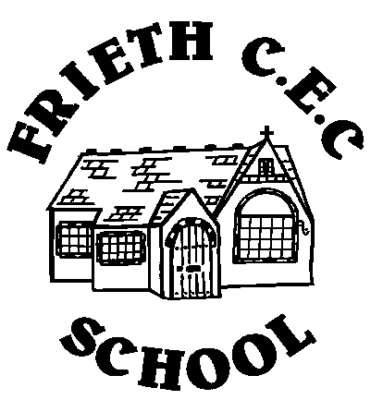**Year 6 Class – Autumn Term I**

|  |  |  |  |  |  |
| --- | --- | --- | --- | --- | --- |
|  | **Monday – NL** | **Tuesday – NL** | **Wednesday – NL** | **Thursday – MG**  **LSA - AC** | **Friday – MG**  **LSA - AC** |
| 8:55 - 9:05 | Registration and  Morning Work | Registration and  Morning Work | Registration and  Morning Work | Registration and  Morning Work | Registration and  Morning Work |
| 9:05 - 10:00 | Maths | English | Big Write | Maths | Maths |
| 10:00 - 10:15 | Collective Worship | Collective Worship |
| 10:15 - 10:30 | B | R | E | A | K |
| 10:30 – 11:30 | English | Topic (History/Geography) | Guided Reading | Maths | French |
| 11:30 - 12:15 | Maths | Spellings | SPAG |
| 12:15 - 1:15 | L | U | N | C | H |
| 1:15 - 2:15 | Swimming/PE  1:15 – 2:45  (yr 6 + 3 + some yr 5) | Science | Music - BlueMic | Computing | PSHE/R.E  Collective Worship |
| 2:15 - 3:15 | Guided Reading  2:45 – 3:15  (yr 6 only) | PE – Premiere Sport  PPA - NL | Art |