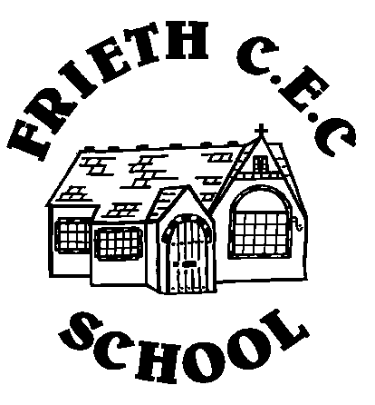
Presentation
at Frieth CEC School

Expectations for Children in KS2

- Use of pencils, pens and rubbers
- Pencils should be used in all books and draft work, if appropriate.
- Pens should be used for all written work, except Mathematics, once a child has received their ‘Pen Licence’ and their teacher judges the child’s handwriting to be sufficiently neat and fluent.
- Pens must be blue handwriting pens. No biros or felt pens should be used.
- Pencils must be HB.
- Felt pens should not be used in exercise books for underlining or illustrations, although they can be used on paper at the teacher’s discretion.
- All children in the school will have stationery provided for them.
- Children in KS2 are allowed to bring one small pencil case to school containing: blue handwriting pen, HB pencil, a small selection of colouring pencils and a pencil sharpener.
- The use of rubbers is discouraged; mistakes should be crossed out with a single line, preferably with a ruler. Rubbers will be available for writing displays and in specific lessons at the teacher’s discretion.

- Layout of written work – KS2
- Use the long date in all books, except for Mathematics.
- Date should be written on the left side of the page, on the top line.
- Leave a line space between the date and the L.O.
- The L.O. should be written on the left side of the page.
- Always leave a line space before starting your work.
- Titles and sub-headings must be underlined with a ruler.
- Self-evaluation must be after the work and on the same page.

