Kites Class Year 4
Yellow highlighted box = taught at school
Green highlighted box = to do at home or if you are a pupil in school in the afternoon.

Day | Maths | English | Other
Mon 22.6.20 | Please then go to WHITE ROSE Planning for WEEK 9 of The Summer Term and follow Lesson 1.  On their website this is marked wc 22.6.20 SUMMER TERM WEEK 9  WE HAVE MOVED ON TO A NEW TOPIC OF MONEY  https://whiterosemaths.com/homelearning/year-4/  LOOK FOR THE LINKS TO VIDEOS, WORKSHEETS AND THE ANSWERS IN THE MATHS BLOCK ON OUR CLASS PAGE  FOR FURTHER WORK AND CHALLENGES PLEASE REFER TO MATHLETICS WHERE YOU WILL FIND LARGE NUMBER ACTIVITIES FROM RANGE OF THIS YEAR’S TOPICS. WHY NOT SET YOURSELF THE CHALLENGE OF COMPLETING 2 OR 3 OF THESE EACH DAY?  ALSO PURPLE MASH FOR SOME GOOD MATHS GAMES | Spelling This week you are looking at words adding the suffix ‘ous’ to words ending with ‘e’. Drop the e but not ge.  famous  nervous  ridiculous  carnivorous  herbivorous  porous  adventurous  courageous  I have attached the Year 4 Spelling A4 Poster  Look through the power point presentation. It will help you understand the spelling pattern.  Then complete your workbook - spelling booklet 3B week 4  Challenge – Do the code word jumble puzzle activity.  Handwriting – Practise writing the words using a cursive script.  Open the Handwriting sheets | Art  This week I would like you to make your own mask. This is a minotaur made from cardboard and fabric.  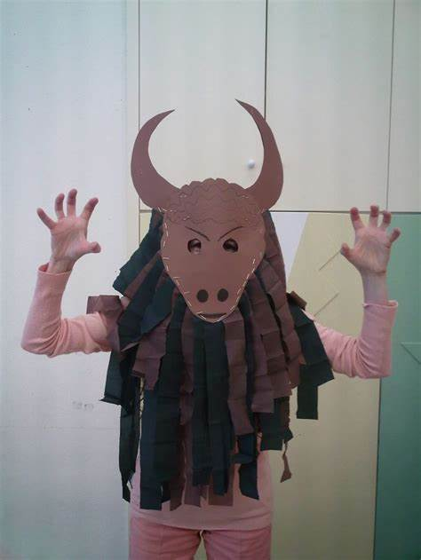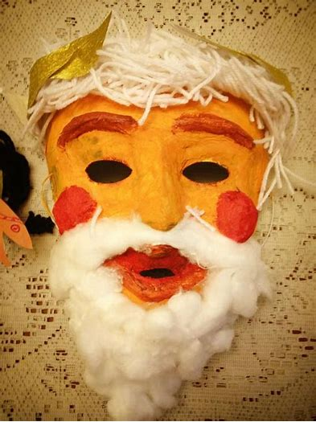  These have been made from paper. This is before they were painted.  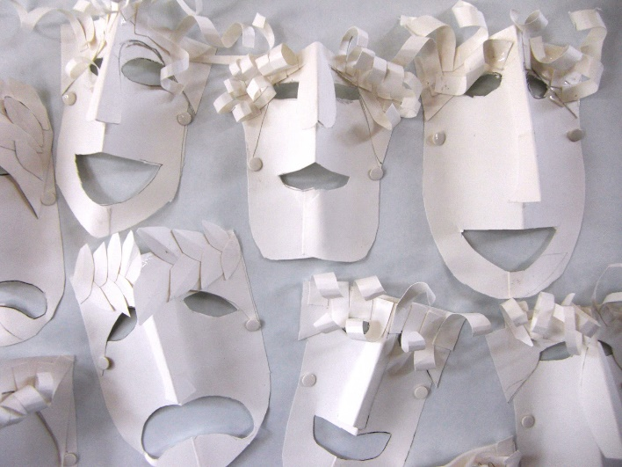  Greek masks had large mouths to project sound all around the theatre. Many masks have survivied so we know what they looked like. Masks were made to be comical or grotesque, depending on the role, They were made from hair, wood, linen and cork. The masks came about from worshippong the god, Zeus.The use of masks meant that actors could play more than one role.  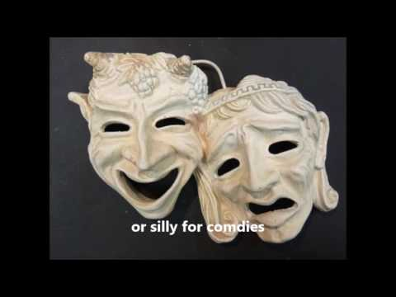  You can choose what materials you want to use.
Tues  23.6.20 | Please then go to WHITE ROSE Planning for WEEK 9 of The Summer Term and follow Lesson 2.  On their website this is marked wc 22.6.20 SUMMER TERM WEEK 9  WE HAVE MOVED ON TO A NEW TOPIC OF MONEY  https://whiterosemaths.com/homelearning/year-4/  LOOK FOR THE LINKS TO VIDEOS, WORKSHEETS AND THE ANSWERS IN THE MATHS BLOCK ON OUR CLASS PAGE  FOR FURTHER WORK AND CHALLENGES PLEASE REFER TO MATHLETICS WHERE YOU WILL FIND LARGE NUMBER ACTIVITIES FROM RANGE OF THIS YEAR’S TOPICS. WHY NOT SET YOURSELF THE CHALLENGE OF COMPLETING 2 OR 3 OF THESE EACH DAY?  ALSO PURPLE MASH FOR SOME GOOD MATHS GAMES | Reading –  - In today's Daily Reading session, we listen to a beautiful poem from the Twinkl Poetry Collection called 'Dragon Song'. The poem takes natural things like the sea and the moon and describes them as though they are living dragons. While reading, children are asked questions about different types of imagery and figurative language, and are encouraged to pause the video to write down their answers. No printer needed as you have the option to type onto the sheet or write your answers on a piece of paper. Additional questions and activities are provided for after the short video. See the attached folder.  - https://www.youtube.com/watch?v=5hCmhSJ6jUk&feature=youtu.be | PSHE –  Take a look at these worksheets. They are all about helping you think positively and recognising all the good things that you have done.  - what questions you have about returning to school? ( for those children returning to school on Monday 28th June.  - Summary of time away from school  - What positives have come from lockdown.
Wed  24.6.20 | Please then go to WHITE ROSE Planning for WEEK 9 of The Summer Term and follow Lesson 3.  On their website this is marked wc 22.6.20 SUMMER TERM WEEK 9  WE HAVE MOVED ON TO A NEW TOPIC OF MONEY  https://whiterosemaths.com/homelearning/year-4/  LOOK FOR THE LINKS TO VIDEOS, WORKSHEETS AND THE ANSWERS IN THE MATHS BLOCK ON OUR CLASS PAGE  FOR FURTHER WORK AND CHALLENGES PLEASE REFER TO MATHLETICS WHERE YOU WILL FIND LARGE NUMBER ACTIVITIES FROM RANGE OF THIS YEAR’S TOPICS. WHY NOT SET YOURSELF THE CHALLENGE OF COMPLETING 2 OR 3 OF THESE EACH DAY?  ALSO PURPLE MASH FOR SOME GOOD MATHS GAMES | Go to BBC bitesize  To understand what synonyms and antonyms are and how they can improve your writing.  This lesson includes:  - one video to help you learn about synonyms and antonyms  - three activities  https://www.bbc.co.uk/bitesize/articles/zk23c7h | FRENCH  Look in the resources on the class page and find your activity from Madame Reynard. You’ll see that see’s done different activities for Y4 and Y5 so make sure you chose the correct one.
Thurs  25.6.20 | Please then go to WHITE ROSE Planning for WEEK 9 of The Summer Term and follow Lesson 4.  On their website this is marked wc 22.6.20 SUMMER TERM WEEK 9  WE HAVE MOVED ON TO A NEW TOPIC OF MONEY  https://whiterosemaths.com/homelearning/year-4/  LOOK FOR THE LINKS TO VIDEOS, WORKSHEETS AND THE ANSWERS IN THE MATHS BLOCK ON OUR CLASS PAGE  FOR FURTHER WORK AND CHALLENGES PLEASE REFER TO MATHLETICS WHERE YOU WILL FIND LARGE NUMBER ACTIVITIES FROM RANGE OF THIS YEAR’S TOPICS. WHY NOT SET YOURSELF THE CHALLENGE OF COMPLETING 2 OR 3 OF THESE EACH DAY?  ALSO PURPLE MASH FOR SOME GOOD MATHS GAMES | Writing  LO To To revise how to write a poem and create one of your own.  This lesson includes:  - one video explaining how to write a poem  - three activities  https://www.bbc.co.uk/bitesize/articles/z97n2v4 | TOPIC ANCIENT GREEKS – THE TROJAN WAR  Here is a Power Point that talks about the Trojan War. In it there’s a page that links to a BBC Bitesize 7 Part animation  https://www.bbc.co.uk/programmes/p08690qz/clips  which you should watch all the way through. If you wanted to do more you could complete the activity sheet of writing a diary entry or produce your own fact file (Word Power Point or old fashioned Poster) about The Trojan War  You might find the fact poster cards and the pictures helpful too.
Fri  26.6.20 | Use today’s maths lesson to at least one of the following.  A TT Rock Stars Sound Check – almost all of you have a highest score of 25 and many of you are averaging 25/25. A few of you haven’t done one for a while… If you haven’t quite managed 25/25 have some practise to see how close you can get. You may even get to 25!  Make sure that you complete the ARITHMETIC TEST in Mathletics that was set last week.  Look at these BBC Bitesize and White Rose challenges  https://www.bbc.co.uk/bitesize/articles/z9ywr2p | Writing  To understand what onomatopoeia is and use it to create a sound poem.  This lesson includes:  - one video about onomatopoeia  - one video of poet Joseph Coelho talking about onomatopoeia  - four activities  https://www.bbc.co.uk/bitesize/articles/zkvyxbk | SCIENCE – THERMAL INSULATORS  Look through the material on Education City under the heading Science 26.6.20 to learn about what materials that have good properties of THERMAL INSULATION.  There is a video of an investigation you could try  https://www.youtube.com/watch?v=Yg8kXf_HKtU  or this really easy one  https://www.youtube.com/watch?v=pVwWjsabDXE  There’s also an online quiz you can do on this subject  https://www.educationquizzes.com/ks2/science/thermal-insulators-and-conductors/  PLEASE ALSO LOOK OUT FOR MISS GREEN’s SCIENE CHALLENGES ON THE SCHOOL WEB SITE WHERE YOU’LL FIND A RESOURCE PACK FOR “30 DAYS WILD” WHICH WILL BE GREAT FUN.

