Kites Class Year 4
Day | Maths | English | Other
Mon 15.6.20 | Please then go to WHITE ROSE Planning for WEEK 7 of The Summer Term and follow Lesson 1.  On their website this is marked wc 8.6.20 SUMMER TERM WEEK 7  https://whiterosemaths.com/homelearning/year-4/  LOOK FOR THE WORKSHEETS AND THE ANSWERS IN THE MATHS BLOCK ON OUR CLASS PAGE  FOR FURTHER WORK AND CHALLENGES PLEASE REFER TO MATHLETICS WHERE YOU WILL FIND LARGE NUMBER ACTIVITIES FROM RANGE OF THIS YEAR’S TOPICS. WHY NOT SET YOURSELF THE CHALLENGE OF COMPLETING 2 OR 3 OF THESE EACH DAY?  ALSO PURPLE MASH FOR SOME GOOD MATHS GAMES | Spelling This week you are looking at words adding the suffix ‘ous’ to words ending with ‘y’ and ‘our’.  various  furious  glorious  victorious  mysterious  humorous  glamorous  vigorous  I have attached the Year 4 Spelling A4 Poster  Look through the power point presentation. It will help you understand the spelling pattern.  Then complete your workbook - spelling booklet 3B week 3  Challenge – Do the which word where activity.  Handwriting – Practise writing the words using a cursive script.  Open the Handwriting sheets | Art  This week I would like you to create an Ancient Greek vase. It will depend on the resources that you have but here are some ideas. If you have a balloon a nd papeir mache kit then you could try this. You might even be lucky enough to have some clay.  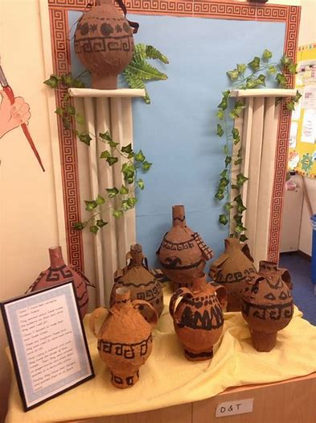  Otherwise you could do this using collage with coloured paper and black pens or black paper.  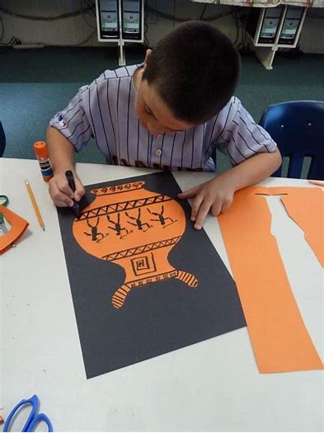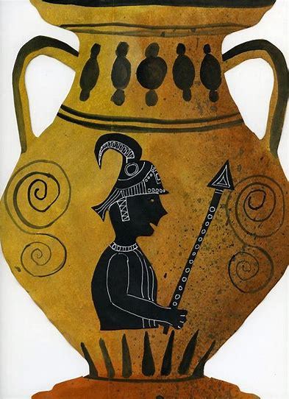
Tues  16.6.20 | Please then go to WHITE ROSE Planning for WEEK 7 of The Summer Term and follow Lesson 1.  On their website this is marked wc 8.6.20 SUMMER TERM WEEK 7  https://whiterosemaths.com/homelearning/year-4/  LOOK FOR THE WORKSHEETS AND THE ANSWERS IN THE MATHS BLOCK ON OUR CLASS PAGE | Reading –  - Read Captain Tom Moore. Choose the right level for you: there are 3 levels to choose from. Once you have read the text then answer the questions using complete sentences. This means the sentence won’t begin with because….  - You can mark your work by looking at the anwers after.  - Having done this I would then like you to write a letter Captain Tom Moore. What would you say to him? | PSHE  This week is refugee week. Here is a video of local people and the work that they have done to support refugees.  There are some suggestions of activities that you might want to do as a family as well as ways of raising money if you would like to.  https://www.youtube.com/watch?v=VeDh6XCIels&feature=youtu.be  PSHE/British Values (respect and tolerance)  LO: I can understand and talk about how we can be responsible global citizens. To consider the feelings and thoughts of others.  Watch video https://www.kazzum.org/refugee-week-2020/primary  How did Dino and Sana feel activity? Pages 16-17 of the Kazzum pdf booklet. The pdf is on the class page.  The theme of Refugee week is IMAGINE  You could:  1) Think about what would your school, community, city, or the planet look like, if you made the rules?  You can take this Simple Act wherever your imagination wants to go, and start as small or as big as you like. Here are some ideas to get your started: • Draw, paint, craft or write a poem or story about the world you want to see • Write a poem or short story starting with ‘Imagine if…’ or ‘Imagine a world where…’ • Imagine you had to leave your home behind. What would you take with you? What would you hope to find?  Stick your imagining in your window, send it to a friend, or share it on social media using #Imagine #SimpleActs  2) Make a Dolls House  Make your own miniature home and be part an international Virtual Giant Dolls’ House for Refugee Week 2020.  The Virtual Giant Dolls’ House project ‘Alone Together’ invites children of all ages to make their own doll’s house in a shoe box. This is an opportunity for young people to share their experience of being stuck at home, while also imagining what it’s like to lose the place where you live.
Wed  17.6.20 | Please then go to WHITE ROSE Planning for WEEK 7 of The Summer Term and follow Lesson 1.  On their website this is marked wc 8.6.20 SUMMER TERM WEEK 7  https://whiterosemaths.com/homelearning/year-4/  LOOK FOR THE WORKSHEETS AND THE ANSWERS IN THE MATHS BLOCK ON OUR CLASS PAGE  . | Grammar  Go to BBC bitesize  https://www.bbc.co.uk/bitesize/articles/zkfvgwx  To understand how to use brackets to add extra information to your writing.  This lesson includes:  - one video about how and when to use brackets  - one video about a Viking story  - three activities | FRENCH  Look in the resources on the class page and find your activity from Madame Reynard. You’ll see that see’s done different activities for Y4 and Y5 so make sure you chose the correct one.  Monsieur Miel now has a 100 day streak with his on line French lessons.
Thurs  18.6.20 | Please then go to WHITE ROSE Planning for WEEK 7 of The Summer Term and follow Lesson 1.  On their website this is marked wc 8.6.20 SUMMER TERM WEEK 7  https://whiterosemaths.com/homelearning/year-4/  LOOK FOR THE WORKSHEETS AND THE ANSWERS IN THE MATHS BLOCK ON OUR CLASS PAGE | Writing LO To write a draft poem  Last week you did a lot of work on improving phrases by adding adjectives and adverbs to the noun and verb in preparation for writing your own poem.  Take a look at the Power Point presentation on Greek Gods and Goddesses. I would then like you to choose one of the gods .  You will be writing a poem about a temple built to honour them.  Draw the temple with the key features that would be placed on it to honour them. Label the drawing clearly so that you know the important parts that you want to write about in your poem. Here is a drawing of the different parts now add your details.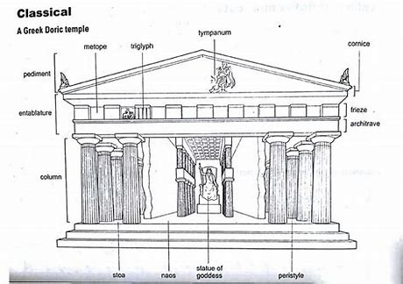  Will it have a statue to the god?  Where is the temple? High on a mountain, by the sea?  What colour is the temple?  Are there any distinctive patterns on the temple like a serpent or a thunder bolt which is a symbol linked to your god?  How do you get to the entrance of the temple?  Remember temples were meant to serve as homes for the individual god or goddess who protected and sustained the community. It was the needs of the gods that were most important. They controlled the forces of nature— the sun and rain, which nourished their crops, and the winds that drove their ships. Gods could turn against the community— so it was in everyone's interest to make sure that they should feel relaxed and at home. Their houses were the finest, equipped with a staff of servants to look after their every need. They received daily offerings of food and drink along with a proper share of the harvest as well as a share in the profits of any trading or military activity.  The god or goddess was represented by a cult image— usually a seated or standing statue— which occupied the central place in the temple. In the early days they would have been made of wood but, over the years, more permanent and costly materials were preferred— stone or cast bronze.  Here are examples of phrases/ lines that could be in a poem but….they would need adjectives to help the reader have a detailed picture of the temple  a) The four steps led up to the door.  b) Everyone stood next to the statue.  c) The path up to the temple was full of rocks.  d) Each pillar was round.  e) The statue was covered in gold.  f) There was an altar in the temple.  Work on your draft today and tomorrow. Look at the peom about the temple could you use this to help you.  Each verse could be 4 lines and remember it does not need to rhyme. | TOPIC ANCIENT GREEK GODS  This week’s topic lesson looks at the gods that the Ancient Greeks worshipped and fits well with the English activity you’ve been doing this week. There is a template to work or you could use your computing skills to present some facts about Greek Gods. There is also a wealth of activity on BBC Bitesize  https://www.bbc.co.uk/bitesize/topics/z87tn39/articles/zgt7mp3
Fri  19.6.20 | Look in Mathletics for the Term 2 Arithmetic Test – You can do this at any time during the week but once you start it you can’t log out and go back to it. It would be a good idea to have some paper handy for your workings. | Writing  Complete your draft for your poem and then produce it in neat. | SCIENCE – Properties of Materials  In SCIENCE we are moving on to our final unit this year which is Materials and their Properties. There’s a power point together with some activities on categorising and testing for different material properties. Again BBC Bitesize has some useful resources  https://www.bbc.co.uk/bitesize/topics/z4339j6/articles/zx8hhv4  PLEASE ALSO LOOK OUT FOR MISS GREEN’s SCIENCE CHALLENGES ON THE SCHOOL WEB SITE WHERE YOU’LL FIND A RESOURCE PACK FOR “30 DAYS WILD” WHICH WILL BE GREAT FUN.

