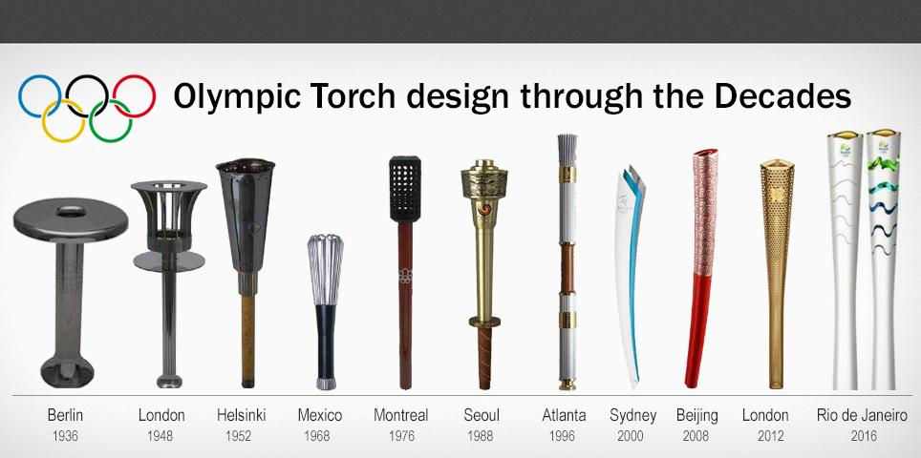
What design do you think a torch for this year should look like?
What does the design reflect?
Who would you get to carry your torch and where would the route go?

