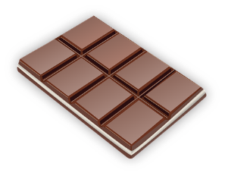  Chocolate | 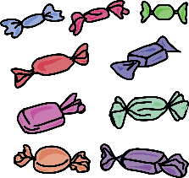  Sweets | 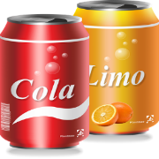  Fizzy drinks | 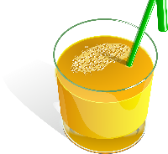  Fruit juice
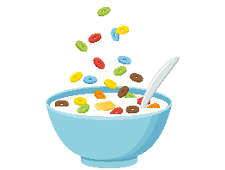  Sweet cereal | 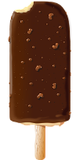  Ice cream | 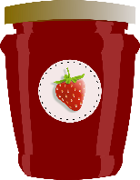  Jam | 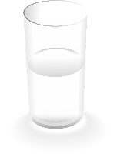  Water
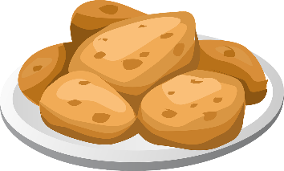  Potato | 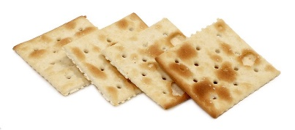  Crackers | 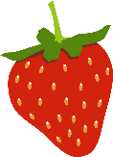  Strawberries | 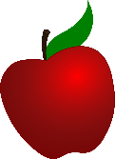  Apples
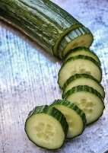  Cucumber | 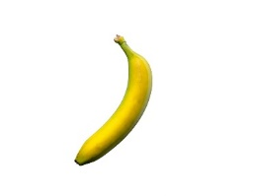  Bananas | 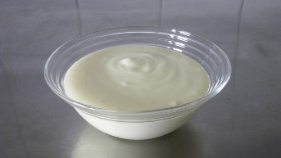  Plain yoghurt | 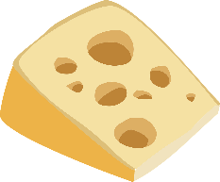  Cheese
Resource 1: Food and drink cards

Resource 2: Steps to brushing teeth
1. Use a small amount of toothpaste (e.g. about the size of a pea)
6. Spit out toothpaste after brushing
5. Brush on the inside of teeth
4. Brush on the outside of teeth
2. Tilt the brush up to the gum
3. Brush in circles and flick down over the teeth

