French home learning Monday 8th June 2020 Y3 and Y4

Quel âge as-tu? Tu as quel âge? J’ai 10 ans.

It’s been such a long time since we practised saying our age! Use the link below to watch High Five video lesson 4, just to refresh your memory.

https://rlneducation.com/p/high-five-french-schools-3months

Why don’t you try to read Les nombres 0-10 forwards and then backwards……

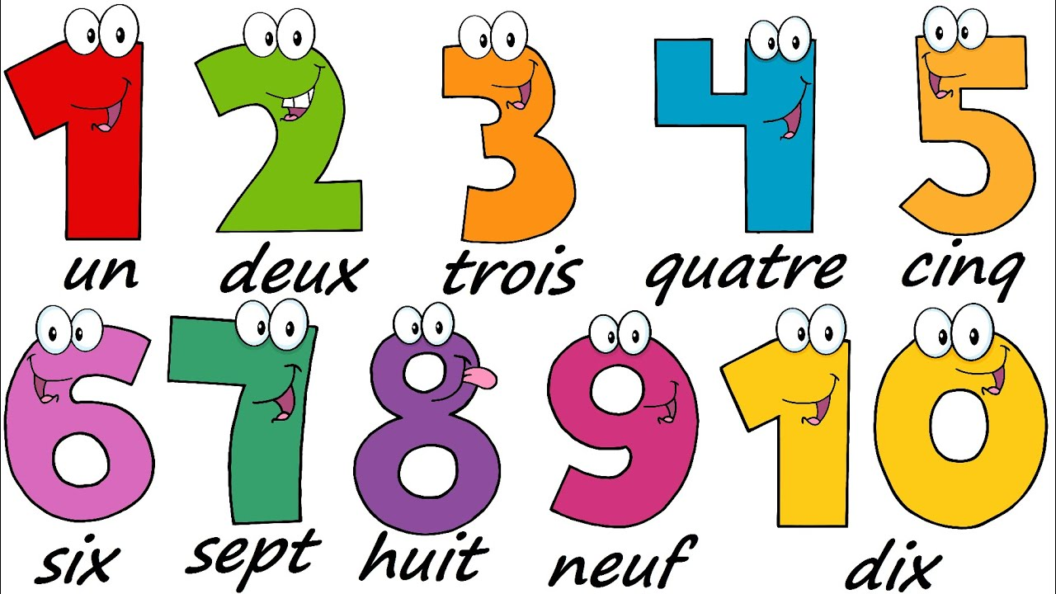

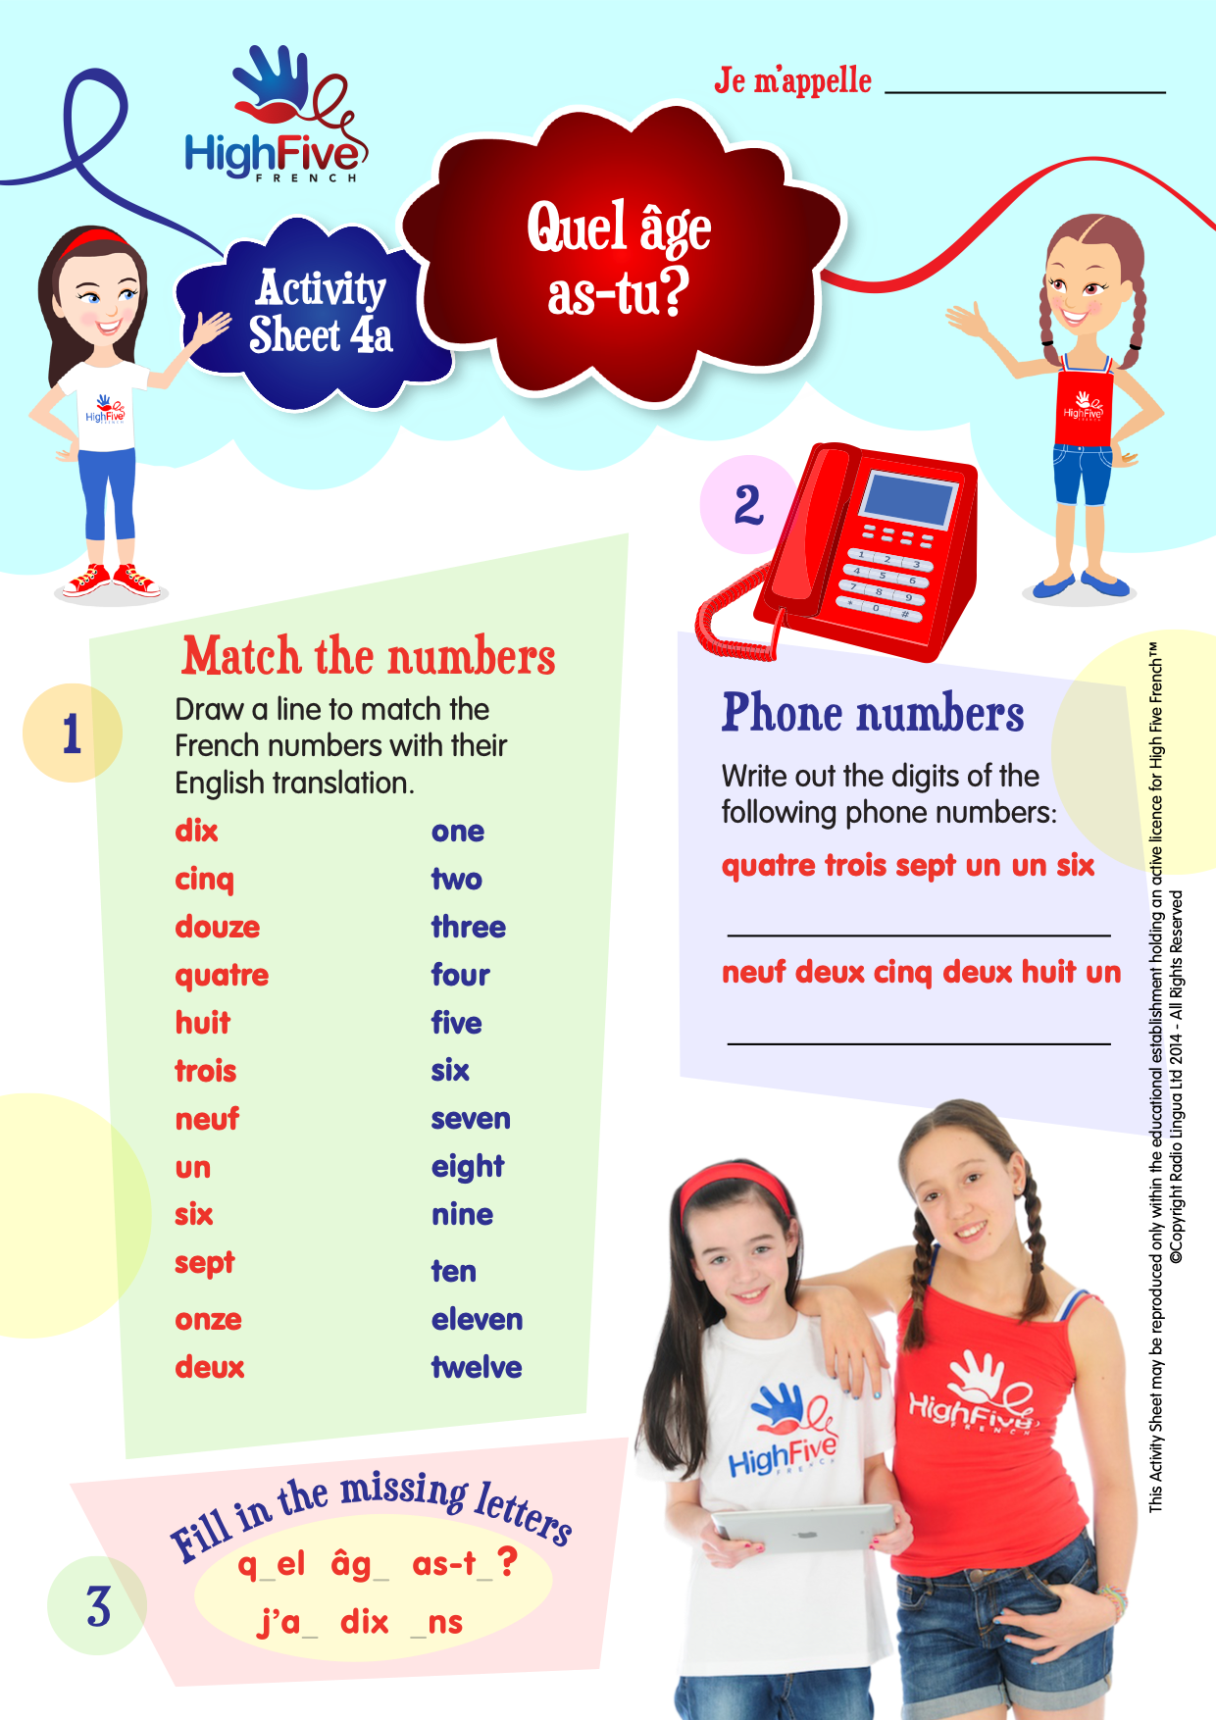

*Don’t forget, you can also ask,”Tu as quel âge?”

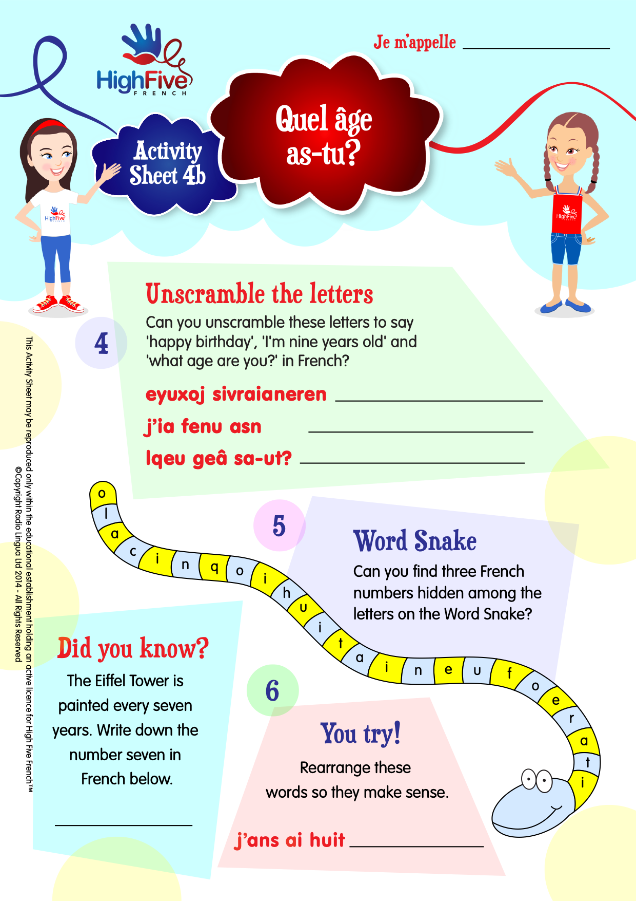

AGE GAME: To play this game you need 2 players, 2 coloured counters and one die. Place your counters on the start arrow. Take turns to throw a die and count round the balloons and presents. When a player lands on a birthday cake, s/he counts the number of candles and says the age represented, e.g.”J’ai 7 ans.” The winner is the first to reach the star!

Quel est ton numéro de téléphone?
Can you work out what this question means? Some of the words look quite like English words: what do you think numéro means? What about téléphone? These words are both called COGNATES. The question means “what is your phone number?” Your challenge is to learn how to say your phone number using the numbers you now know, and there’s one extra number you’ll need to recall: how do you say “zero” en français?
(“zéro” – remember?) That’s your challenge for this lesson!

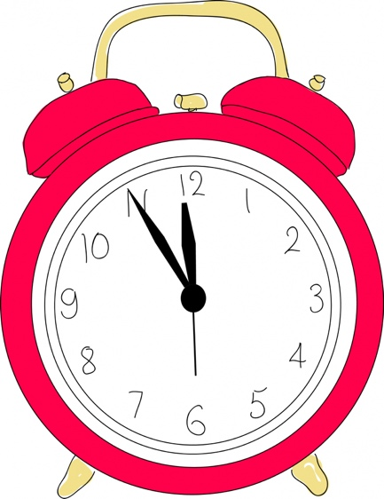

If you follow the link below you can try to beat the clock in a simple maths challenge adding Les nombres 0-12 en français.

https://www.educandy.com/site/resource.php?activity-code=22878

“Un sandwich Renard!”
(Do you notice anything about the name of this sandwich?!)

There are no actual instructions to follow for this recipe. I am sure you can make this sandwich by simply looking at the picture, but don’t forget your bilingual dictionary if you have one – or click on the link to the online one below to check that you have the right ingredients.

https://www.collinsdictionary.com/dictionary/english-french

Ingrédients:
Du pain
Du jambon
Du fromage en tranches
Des olives noires

Bon appétit! Miam, miam!

