Week beginning Monday 20th April 2020
Welcome to the FRIETH KS2 French home learning page!

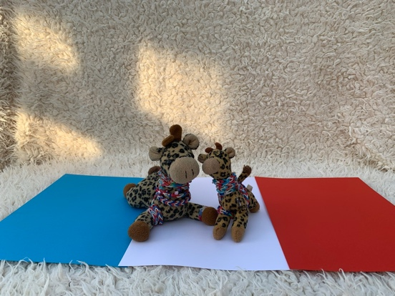

It has been such a long time since we have been together. The Home Learning will help you to refresh what we have learnt in our lessons, while at the same time allow you to be creative, which is great for your wellbeing. This week we will start with something super simple!

Minou and Minette really hope that you enjoy the activities. You do not have to do everything, just have a try, we want you to enjoy the tasks. We would all love to see whatever you tackle, so be sure to keep it in a safe place! Try this to get active and revise your greetings (a must for footie fans!)

https://www.bbc.co.uk/teach/supermovers/ks1--ks2-mfl-french-greetings-with-ben-shires/zdpdvk7

I would like you to ask a grown up in your family to subscribe to the following online language website so that we can use lots of their activities for free while we are learning at home. It is called High Five Languages. You need to select ‘High Five French (3-month Free Access)’

https://rlneducation.com/p/high-five-french-schools-3months

- Watch the first video ‘Introducing Emma and Mathilde.’ As you watch, see if you can spot any well known French landmarks.
- Now watch video lesson 1 – you can revise how to greet people, it’s very simple and it is very short!
- You will see ‘Activity Sheets’ in the contents list. Try the sheet for Lesson 1 – maybe you could create a colourful poster with some of the greetings words from the video.

1.
- Feel free to explore everything in the contents list for lesson 1 – whenever you have time – just to get used to using High Five French.

- Below is a recipe (en français of course!) for some football biscuits. You should be able to follow the recipe by looking at the pictures, the numbers and of course looking for cognates! You can also use your bilingual dictionary to help you at any time. If you do not have one, you can use the online one:

- https://www.collinsdictionary.com/dictionary/english-french

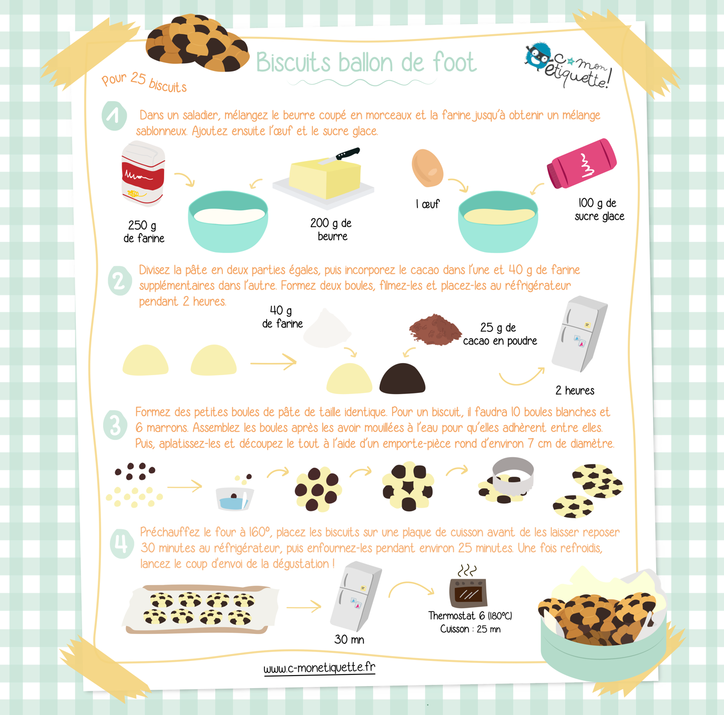

Maybe you can take some photographs of your yummy biscuits…

Bon appétit!

2.

