[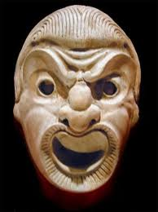](https://www.google.co.uk/url?sa=i&rct=j&q=&esrc=s&frm=1&source=images&cd=&cad=rja&docid=5ZsjJe5PEeE4EM&tbnid=cokF7fRdf8b9_M:&ved=0CAUQjRw&url=https%3A%2F%2Fwww2.bc.edu%2F~shammom%2Fhonors4fall.html&ei=NbtiUZTZIMLA0QWv1IHwBQ&bvm=bv.44770516,d.d2k&psig=AFQjCNE4CcvAibCc8AGmTQRSvigr0PqtKA&ust=1365511312148244)Greek Theatre Masks

[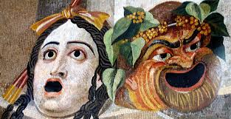](http://www.google.co.uk/url?sa=i&rct=j&q=&esrc=s&frm=1&source=images&cd=&cad=rja&docid=m8-OQ4YamKYKMM&tbnid=GUtC-ss7EpmDEM:&ved=0CAUQjRw&url=http%3A%2F%2Feveryhistory.org%2Fwestern_literat%2F8.html&ei=xbtiUeKwH4nK0QXStoDYBw&bvm=bv.44770516,d.d2k&psig=AFQjCNE4CcvAibCc8AGmTQRSvigr0PqtKA&ust=1365511312148244)[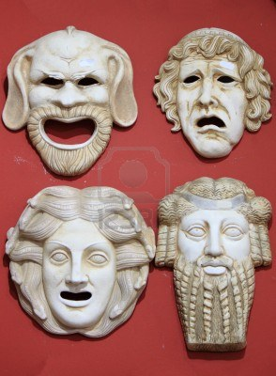](http://www.google.co.uk/url?sa=i&rct=j&q=&esrc=s&frm=1&source=images&cd=&cad=rja&docid=SoHq0OhMVpgfhM&tbnid=7lSu-QaW65isoM:&ved=0CAUQjRw&url=http%3A%2F%2Fwww.123rf.com%2Fphoto_14964017_ancient-greece-theatre-masks-in-marble-stone.html&ei=kbtiUcCSAoSo0wXI94CQBw&bvm=bv.44770516,d.d2k&psig=AFQjCNE4CcvAibCc8AGmTQRSvigr0PqtKA&ust=1365511312148244)[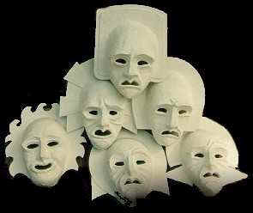](http://www.google.co.uk/url?sa=i&rct=j&q=&esrc=s&frm=1&source=images&cd=&cad=rja&docid=zKV8xABBahvbOM&tbnid=sMVEN8zgTCl1OM:&ved=0CAUQjRw&url=http%3A%2F%2Finverseintuition.org%2Fstudents%2Fbcc%2Fhumanities%2Fhum1%2Fprojects.html&ei=ebtiUbzYH6Kl0QWQ9oH4BQ&bvm=bv.44770516,d.d2k&psig=AFQjCNE4CcvAibCc8AGmTQRSvigr0PqtKA&ust=1365511312148244)[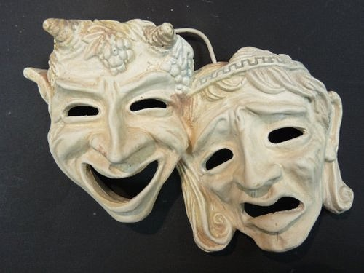](http://www.google.co.uk/url?sa=i&rct=j&q=&esrc=s&frm=1&source=images&cd=&cad=rja&docid=-rYki_RXmEmzIM&tbnid=toEcS7_IfUBpQM:&ved=0CAUQjRw&url=http%3A%2F%2Fgenelempp.wordpress.com%2F2011%2F10%2F12%2Fdesigning-from-bones-theatrical-roots%2F&ei=VLtiUfL7OYr40gW88oC4Bg&bvm=bv.44770516,d.d2k&psig=AFQjCNE4CcvAibCc8AGmTQRSvigr0PqtKA&ust=1365511312148244)[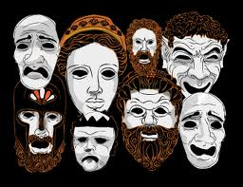](http://www.google.co.uk/url?sa=i&rct=j&q=&esrc=s&frm=1&source=images&cd=&cad=rja&docid=sPHGib4uIeXosM&tbnid=-81wEjieK1SZFM:&ved=0CAUQjRw&url=http%3A%2F%2Fartsedge.kennedy-center.org%2Finteractives%2Fgreece%2Ftheater%2FplayersProps.html&ei=FLtiUf37KMqU0QXlloHwBQ&bvm=bv.44770516,d.d2k&psig=AFQjCNE4CcvAibCc8AGmTQRSvigr0PqtKA&ust=1365511312148244)Look at the examples, think of the features, can you identify the emotion?