Week beginning Monday 11th May 2020
Welcome to the French home learning page.

“Bonjour tout le monde!”

- This week we are going to watch High Five video lesson 7.
It is all about ‘Les couleurs,’ which is a COGNATE isn’t it?
Use the link below:

https://rlneducation.com/p/high-five-french-schools-3months

- You will see ‘Activity Sheets’ in the contents list. Try both worksheets for Lesson 7.

If you follow the link below you will be able to practise reading and spelling ‘Les couleurs,’ by playing games like Hangman. Some of the games are against the clock. Enjoy!

https://www.educandy.com/site/resource.php…

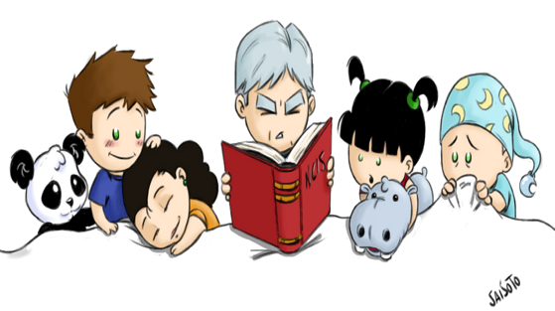
This Photo by Unknown Author is licensed under CC BY-NC-ND

https://youtu.be/N-94JbM_A1Q

If you click on the link above, you will see that I have read a story which you might like to listen to. It is all about colours and is called, “Va t’en grand monstre vert!” which means,
“Go away big green monster!”

‘L’arc-en-ciel.’

I am certain that you have drawn at least one rainbow picture by now!

L’arc-en-ciel (pronounced ‘Lark-on-see-ell’ and don’t forget to purr like a happy cat for the letter ‘r’) means rainbow – you can also describe something as rainbow coloured, for example:

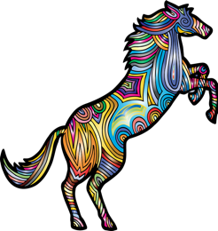 | 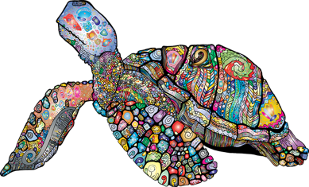
Le poney arc-en-ciel  (The rainbow coloured pony) | La tortue arc-en-ciel  (The rainbow coloured tortoise)
*Remember that many adjectives en français go after the noun.

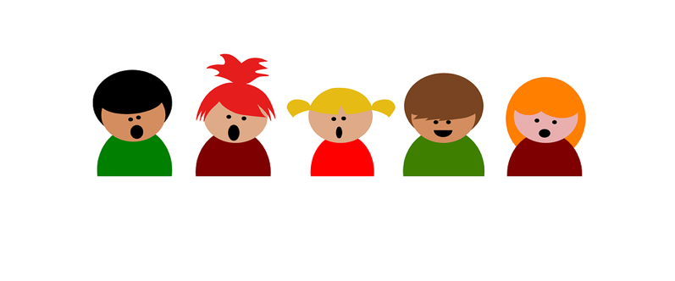
Listen to the, ‘Thank you NHS,’ rainbow song with Madame Cantin. Can you join in with her?

https://youtu.be/sGA6W4vPjak

After all that hard work why don’t you prepare yourself something délicieux to eat, miam, miam! (Yum, yum!)

‘L’arc-en-ciel fruité de l’été.’
(Summer fruits rainbow.)

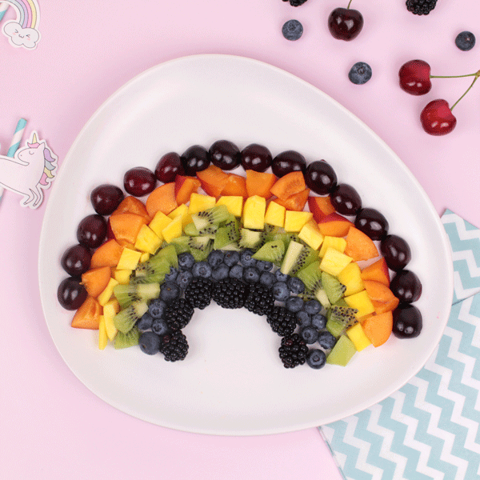

Ingrédients:
Des cerises, des pêches, des ananas, des kiwis, des myrtilles et des mûres.
You can probably work out most of the words by looking at the picture and looking for cognates. For those words which are slightly more tricky, don’t forget to use your bilingual dictionary or the online one:

- https://www.collinsdictionary.com/dictionary/english-french

I would really love to see some pictures of your delicious
‘Summer fruits rainbow.’

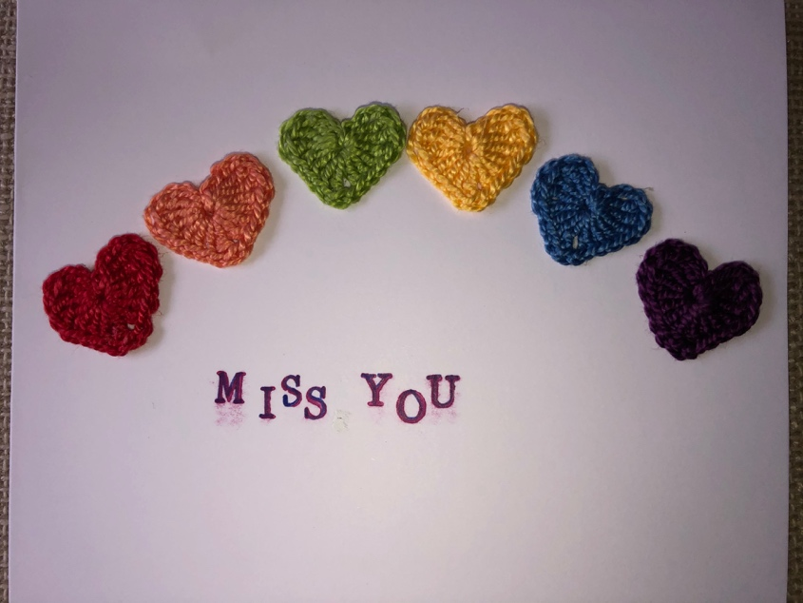

Les microbes
4.4
r
w
f
.
w
e
t
w
t
e
u
i
q
c
.
-
m
o
n

