Week beginning Monday 18th May 2020
Welcome to Kestrels French home learning page.

“Les couleurs.”
- Use the link to watch High Five video lesson 7 again, just to refresh your memory about ‘Les couleurs’ and how to pronounce them correctly.

https://rlneducation.com/p/high-five-french-schools-3months

“Beat the clock.”

- Colour in the drawings on the next two sheets to match the labels.
- Cut out the cards.
- Use the cards to play Matching Pairs or Snap with a partner.
- If you don’t have a partner, you can simply turn all the cards over, so that you can’t see them, jumble them up and then race against the clock to turn them over and match them up correctly. Why don’t you play several times and try to beat your time!
- CHALLENGE: Can you arrange all the colour word cards into alphabetical order?

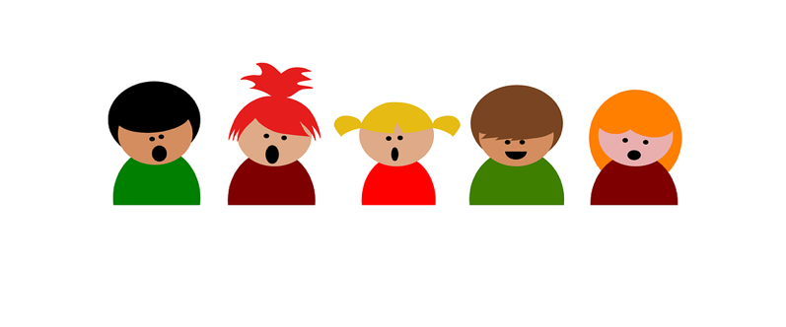
Listen to the, ‘Les couleurs,’ song.
Can you join in?
https://youtu.be/-4kNeFGBAcw
Time for something relaxing!

Colorie en respectant le code:
Bleu = un | Rose = cinq | Vert = huit
Jaune = deux | Orange = six | Gris = neuf
Noir = trois | Rouge = sept | Violet = dix
Marron = quatre

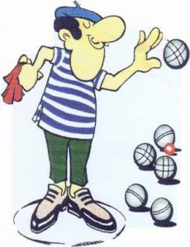

Have you heard of the French game called, ‘Boules?’ It is sometimes called, ‘Pétanque.’ Can you find out how to play these games? Are there differences between the two games? They are very, very popular indeed throughout France and are played very seriously. Perhaps you have your own set of boules at home. Does your set look like the sets in the
photographs? Maybe you can play some games in your garden? I would love to see some pictures….

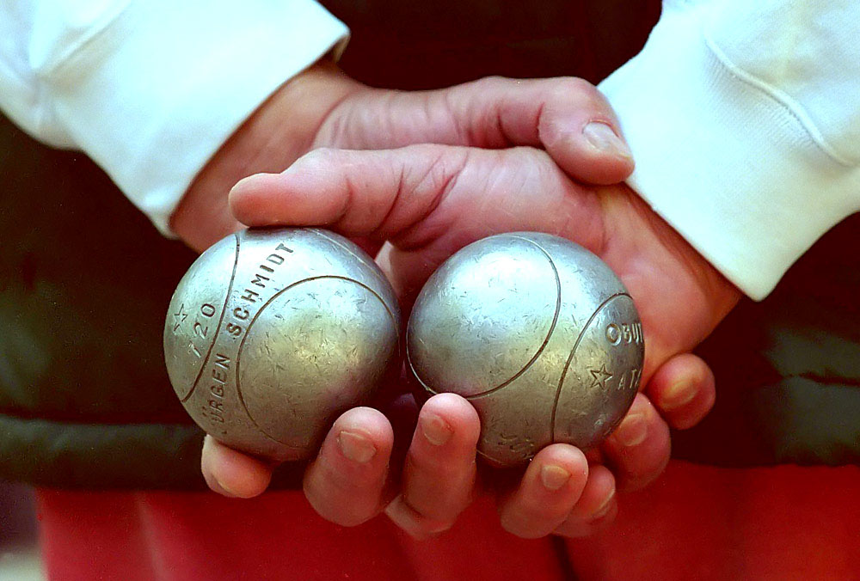
This Photo by Unknown Author is licensed under CC BY-SA

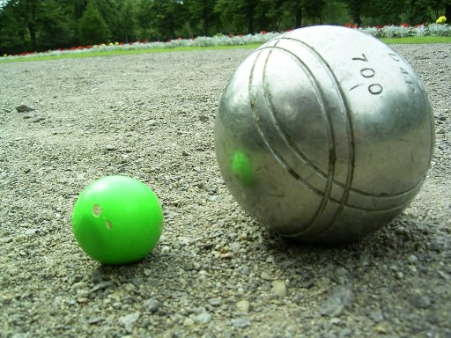
This Photo by Unknown Author is licensed under CC BY-SA
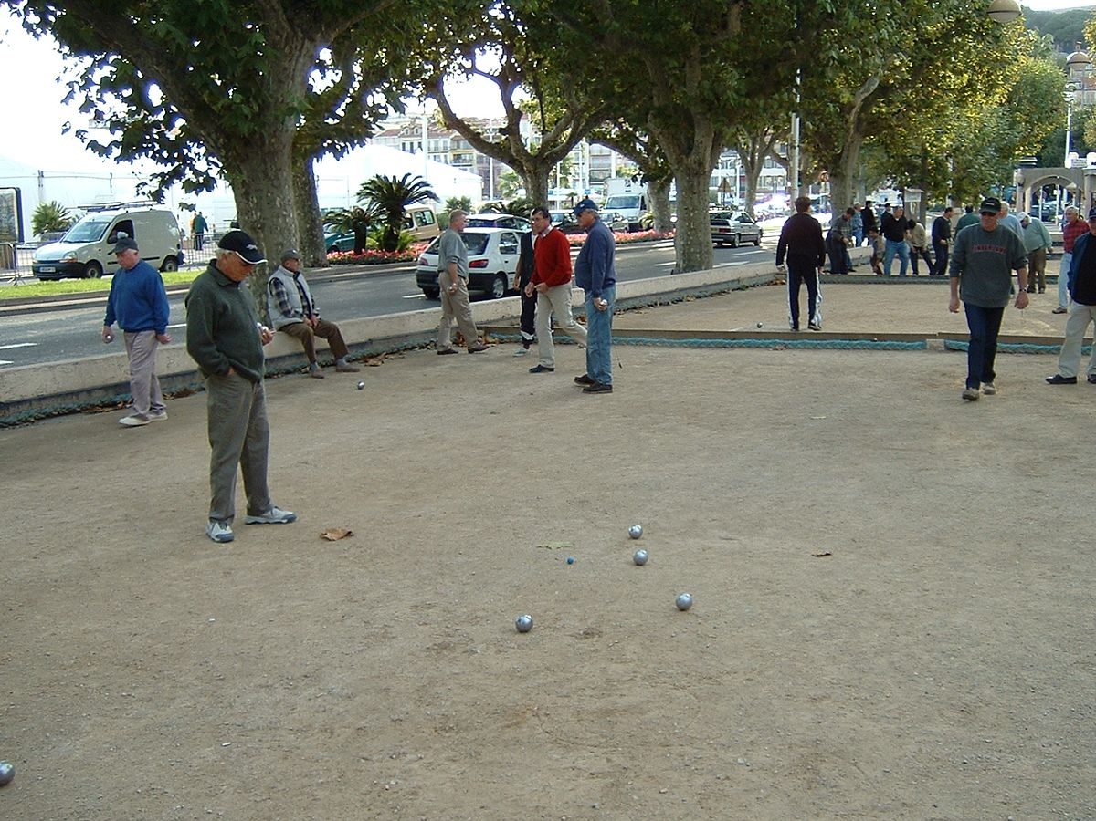
Les microbes

You might have a set that looks like the one in the picture below. I have one like it. We use it to play in the garden and on the beach.
w
e
t
w
t
e
u

How well do you know your colours now?q
Can you unjumble the colours? I have done the first one for you…
leub | blue
egruo
cblna
seor
teoivl
gaenor
sigr
jeuan
rnio
rtev
rmoanr

Time for a little poetry…..
Can you use some pictures, look for cognates and use your bilingual dictionary to help you to read this famous French poem? You might need to use an online dictionary:
https://www.collinsdictionary.com/dictionary/english-french

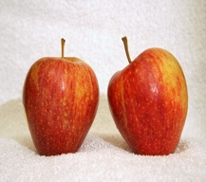
“Crayons de couleur.”
This Photo by Unknown Author is licensed under CC BY-SA
Le vert pour les pommes et les prairies,
(Green for the apples and the prairies,)
Le jaune pour le soleil et les canaris,
This Photo by Unknown Author is licensed under CC BY-SA
Le rouge pour les fraises et le feu,
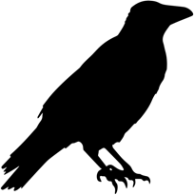
Le noir pour la nuit et les corbeaux,
Le gris pour les ânes et les nuages,
Le bleu pour la mer et le ciel,
Et toutes les couleurs pour colorier
Le monde.
By Chantal Couliou

