Fingerprinting: A Lesson on Classification

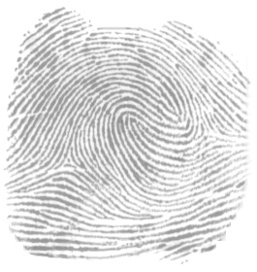
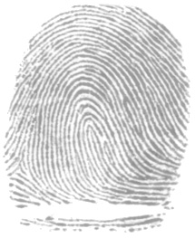
This lesson developed by Reach Out!

Guiding Question:

Can we invent a way to classify fingerprints?

Objectives

Facts:
- The patterns of ridges on our finger pads are unique: no two individuals—even identical twins—have fingerprints that are exactly alike.
- We leave impressions—or prints—of these patterns on everything we touch with any pressure.
- The prints can be visible, as when our fingers are dirty or oily, or they can be latent, as when they are made only by the sweat that is always present on our finger ridges.
- Injuries such as burns or scrapes will not change the ridge structure: when new skin grows in, the same pattern will come back.
- Dactyloscopy is the practice of using fingerprints to identify someone.
Principles:  - Fingerprints can be classified by pattern types, by the size of those patterns, and by the position of the patterns on the finger.  Skills:  - Observing  - Comparing and contrasting  - Classifying  Materials:  - White paper or card  - pencils  - transparent tape;  - good lighting  - hand magnifiers—nice to have but not essential | 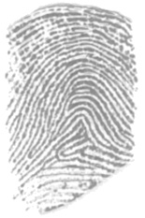
 | 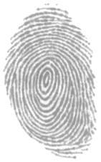

Introduction
Can we invent a way to classify fingerprints?
If you want to use fingerprints to solve crimes, you must have a way to describe and sort and find prints that are similar to the one you find at a crime scene. The FBI has over 200 million prints on file; they can’t look through every single one to find a match!
Today we are going to look at some of our fingerprints and see how we might sort them into categories, just as fingerprint specialists do.

Activity
- Make sure you have everything you need
- You will be making prints of your index finger and the middle finger of the same hand. Use the hand you write with.
- Note you will want to make prints not of your fingertips but of the pads of your fingers, near the joint crease, because that is where the most interesting patterns are.
- Cover your finger pad with pencil (you may want to create some powder by rubbing your pencil onto a scrap piece of paper then using this as your pencil/ink pad)
- Carefully stick a short piece of tape to the finger pad area, pressing down thoroughly, remove the tape and press it onto your print record card or into your science book.
- Label your print “L” or “R” for left or right hand and “I” or “M” for index or middle finger.
- Repeat procedure for the second finger. Repeat until you get two good prints.
- After all prints are made and labelled, compare your prints for similarities and differences with the example prints.
  - Are the two prints from the same hand more alike than prints from different people? How?
  - What kinds of patterns do they see? (circles, triangles, curvy lines)
  - Compare your own prints to the handout with examples of “official” names for patterns (loops, whorls, and arches).
  - What are the positions of those patterns on the finger (how close they are to the joint line)?
  - In which direction do the loops curve—toward the thumb or toward the pinkie finger? (Remember that taped prints are like looking at your finger palm-up and inked prints are mirror images. It may be easier to ask whether they curve toward the right or left of the card.)
  - Compare the size of those patterns (such as how many ridges make up a loop).
Note that, while scars, such as the white line on one of the sample prints in this lesson, are the easiest patterns to see, they cannot be used either for classification or identification. They are not unique in the way that ridge patterns are, and they also change over time—making them unreliable for these purposes.
- Sort the prints from the class (or your family if working from home) by patterns, either grouping them physically or grouping their cards by pattern.
- Ask how you might look most efficiently for a particular pattern. For example: “In which of these groups would I look for a loop that leans to the left? Would it make sense to look through the whorls?”
- Which is the most common pattern? You may wish to graph results, or to figure fractional or percentage representation of each type.
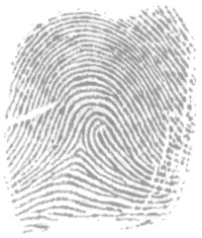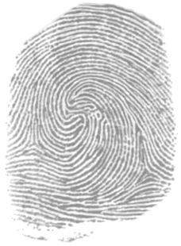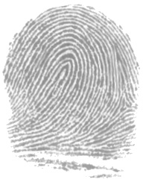
- How can fingerprints be classified?
- How would classification make it easier to match one print against a database of many?
Look for evidence of a plan to search systematically: for example, to look through the left-leaning loops with eight ridges that are close to the finger joint.
Final Note: Fingerprints are a very personal kind of information; let participants take their prints home with them.

Extension Ideas
If you have time, there are many ways to further investigate both fingerprints and classification.
- You can create a mock “crime scene” with a single print from one of your group and time participants while they find a match by examining every single print. Then duplicate another mystery print and your complete database of prints for teams. First, let them take as long as they like to classify the prints, and then time them again to see who can find a match for the mystery print most quickly using their classification system. How do their systems vary and why would some be more efficient than others?
- Investigate differences: does age, sex, or race seem to predict type of pattern? Children can compare their prints to those of siblings and parents for evidence of hereditary influence.
- Compare finger and toe prints. Investigate pet bird toe prints.
- If children can bring in ceremonial birth certificates with their own footprints, how do they compare to their present-day footprints?

There are many sites on the Web related to fingerprinting. Here are a few:
- More on fingerprint classification
- See Ed German’s Latent Print Examination site, including lots of news and interesting related links, plus his Frequently Asked Questions, including whether fingerprints are inherited
- Fingerprint FAQ’s (frequently asked questions, referred to above) - tailored for elementary students, John Q. Public, police officers, and criminals
- See the on-line History of Fingerprints
- For extensive technical information, see the FBI’s on-line Handbook of Forensic Services
- Download the FBI’s Latent Print Processing Guide 2000 (70 pages!) in PDF form — also very technical!

Careers Related to Lesson Topic
Find information from the Dept.of Labor on protective services occupations:
- Correctional Officers and Bailiffs
- Fire Inspectors
- Police and Detectives
- Private Detectives and Investigators
- Security Guards and Gaming Surveillance Officers

Prerequisite Vocabulary
Classify
To sort into groups by likenesses and differences
Latent
Present and not able to be seen but capable of becoming visible. Used to describe fingerprints that are not visible until they are dusted with chalk or other powders, or until they are lit with a laser
Visible
Capable of being seen by the eye without help

Fingerprint Patterns
Left-leaning loop | Right-leaning loop | Whorl

Double loop | Double loop with central pocket

Plain arch | Tented arch | Arch with loop & scar
