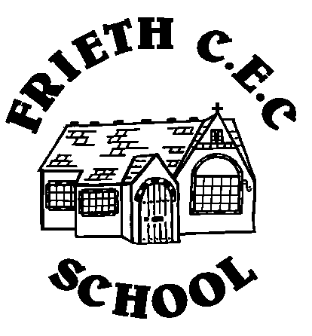
Kites Class – Summer Term 1

 | Monday – MB, PA | Tuesday – MB, PA | Wednesday – MB, PA, AD (pm) | Thursday – MB, PA | Friday – MB, SC
8:55 - 9:05 | Registration and  Morning Work | Registration and  Morning Work | Registration and Spelling Test | Registration and  Morning Work | Registration and  Morning Work
9:05 - 10:00 | Maths | Maths | Maths | Maths | Maths
10:00 - 10:15 | Collective Worship | Collective Worship | Collective Worship | Collective Worship | Maths
10:15 - 10:30 | B | R | E | A | K
10:30 – 11:30 | Guided Reading  10.30-11.00 | SPAG | Guided Reading | SPAG | Guided Reading/SPAG
11:30 - 12:15 | English | English | English | English | English
12:15 - 1:15 | L | U | N | C | H
1:15 - 2:15 | Science | P.E. Outdoor | Forest School | P.E. (indoor) | Topic
2:15 - 3:15 | PSHE | Topic | Forest School | French  (Mrs Crowther) | Topic
 |  |  |  |  | Celebration

