**TOOTH DECAY and STAINING EXPERIMENT WITH EGG SHELLS**

We can’t experiment on our own teeth so we will again use eggs to represent them, as the shell of an egg is made of a similar substance to tooth enamel. You will need 3 eggs but, as I suggested last week you could contact a friend and agree to work together so as not to waste eggs.

This is a list of **EQUIPMENT**

[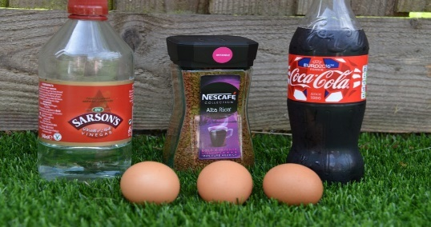](https://www.science-sparks.com/wp-content/uploads/2015/05/DSC_5550.jpg)Eggs

Jars

Water

Tea/Coffee

Fizzy flavoured drink

Vinegar

Toothpaste

Here is the **METHOD**

[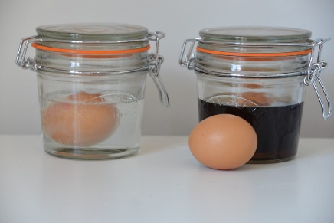](https://www.science-sparks.com/wp-content/uploads/2015/05/DSC_5553.jpg)

Pour the same amount of fizzy drink, vinegar, water and tea or coffee into your jars.

Add a whole raw egg still in its shell to each, cover an extra egg with toothpaste and also place in tea/coffee.

Make some **PREDICTIONS** as to what will happen over the course of 5 days

After 5 days, remove the eggs and describe (perhaps you could take photographs to support your **OBSERVATIONS**).

Rinse the egg kept in vinegar and rub gently until the shell comes away. How has it changed?

What about the “coffee” eggs?

What have you discovered? What can you **CONCLUDE** from this?

Can you find the scientific reasons for the change in the egg left in vinegar?

If you did a similar experiment last week with orange juice, were there any similarities?

What could you advise a dentist to say to their patients?