 | Monday |  | Tuesday |  | Wednesday |  | Thursday |  | Friday
 | Miss Rackstraw |  | Miss Rackstraw |  | Miss Rackstraw |  | Miss Rackstraw |  | Miss Rackstraw
 | Miss Goodey |  | Miss Goodey |  | Miss Goodey |  | Miss Goodey |  | Miss Goodey
 |  |  | Mrs Douglas |  |  |  | Miss Birmingham
 |  |  | Miss Birmingham
8:45 – 8:55 | Self- Registration |  | Self- Registration |  | Self- Registration |  | Self- Registration |  | Self- Registration
8:45 – 8:55 | Morning Song/ Work |  | Morning Song/ Work |  | Morning Song/ Work |  | Morning Song/ Work |  | Morning Song/ Work
9:00 – 10:00
9:00 – 10:00 | Phonics and |  | Phonics and |  | Phonics |  | Phonics |  | Phonics and
9:00 – 10:00 | handwriting |  | handwriting |  |  |  |  |  | Handwriting
9:00 – 10:00 | Continuous Provision |  | Continuous Provision |  | Continuous Provision |  | Continuous Provision |  | Continuous Provision
10:00 - 10:15 | Fruit and milk |  | Fruit and milk |  | Fruit and milk |  | Fruit and milk |  | Fruit and milk (snack café)
10:00 - 10:15 | Singing Assembly |  | Assembly |  | Assembly |  | Collective Worship (in class)
10:15 - 10:30 | B |  | R |  | E |  | A |  | K
10:30 – 12:00 |  |  |  |  |  |  | English/ Handwriting |  | PE
10:30 – 12:00 |  |  | Maths |  | Maths
10:30 – 12:00 |  |  |  |  |  |  | Continuous Provision (adult-lead tasks)
10:30 – 12:00 | PE |  | Continuous Provision (adult-lead maths task) |  | Continuous Provision (adult- lead maths task)
12:15 - 1:15 | L |  | U |  | N |  | C |  | H
1:15 – 1:30 | Registration |  | Registration |  | Registration |  | Registration |  | Registration
1:15 – 1:30 | Topic input |  | Story |  | English/ Handwriting input |  | Maths input |  | Story
1:30 – 3:00 |  |  | Forest School |  |  |  |  |  |  | Continuous Provision
1:30 – 3:00 | Topic | Continuous Provision | Forest School |  | English/ Handwriting | Continuous Provision | Maths  Adult- lead task | Continuous Provision |  | Continuous Provision
1:30 – 3:00 | Adult-led task |  | Forest School |  |  |  |  |  | Helicopter stories | Continuous Provision
1:30 – 3:00 | Story |  | Forest School |  |  |  |  |  |  | Continuous Provision
1:30 – 3:00 |  |  | Forest School |  | Story |  | Story
1:30 – 3:00 |  |  |  |  |  |  |  |  | Assembly
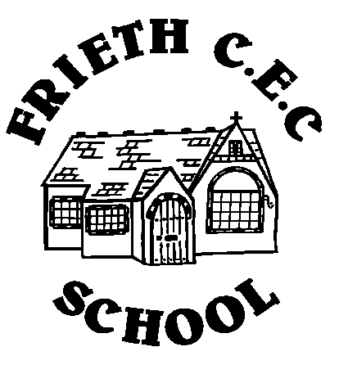
Owls Autumn Term I

